                - School Nutrition Projects
                - Nutrition Guidelines

Contents
Introduction 3
What foods can be part of SNP? 3
Food and Drink Table 4
Steps to assessing an item with a Nutrient Information Panel 10
Steps to assessing an item with no Nutrient Information Panel 11
Example of a 4 week menu 16
Recipe Ideas 18
Spaghetti Bolognaise 18
Easy Quiche 18
Chicken Noodle and Sweet Corn Soup 19
Shepherd’s Pie 19
Resources 20
Acknowledgement 20
Appendix 1 - The Aboriginal and Torres Strait Islander Guide to Healthy Eating 21

Introduction
Children need healthy food to grow and thrive. NT Health developed this handbook to assist School Nutrition Projects (SNP) providers to offer healthy food. SNP is funded by the Australian government's Indigenous Advancement Strategy. All SNPs should meet the NT Department of Education’s School Nutrition and Healthy Eating Policy. This guide is intended to help you do just that.
For nutrition advice related to SNP, talk with your local Nutritionist or SNP Coordinator.
- Top End: NutritionOutreachTE@nt.gov.au
- Central Australian: NutritionOutreachCA@nt.gov.au
- Big Rivers Region: NutritionBRR.DOH@nt.gov.au
- Urban Alice Springs: phone 8951 6711
- SNP Coordinators: ChildrenandSchoolingProgramme@pmc.gov.au

What foods can be part of School Nutrition Project (SNP)?

There are three types of food and drinks in this guide.

Go! Always on the menu
These foods and drinks are the best choices. These should make up most of your menu. They contain lots of nutrients and are generally low in saturated fat and/or sugar and/or salt. Offer these “Always on the menu” foods and drinks every day.

 Slow - Select Carefully

These foods and drinks contain some valuable nutrients. They also have some saturated fat and/or sugar and/or salt. Eating these foods often or in large amounts can be a problem.
To offer “Select Carefully” foods safely
- Keep the serve size small.
- Offer less select carefully and more “Always on the menu” foods.
- Asses some of the “Select Carefully” foods against the Nutrition Criteria (page 8 & 9).

 Stop! Not on the menu

These foods and drinks must not be served as part of the school nutrition project (SNP). They are low in nutritional value.

Use the table on the following pages to select food and drinks for your school nutrition project (SNP).
A note about food allergies. Always check if your school has children who have allergies before you plan your menu. We have highlighted nuts in this guide. If your school is nut free or nut aware do not include nuts on your menu. However, children can be allergic to many things, not just nuts. You might like to complete some online training if you are not sure how to manage food allergies Food Allergy Training.

Food and Drink Table
Food Group |   Go!  Always on the menu  These foods are the best choice and should be most of your menu. |   Slow -  Select Carefully  Chose less of these and keep the portion size small. |   Stop!  Not on the menu  Do not provide these foods as part of the SNP.
Bread  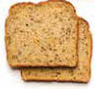 | Multigrain, wholegrain, rye, wholemeal and white high fibre bread.  Bagels, wraps, crumpets, focaccias, gluten free bread, pita, Turkish bread, Pita bread, tortillas and English muffins,  Raisin and fruit bread.  Damper made with iron fortified flour.  Un-iced fruit buns and glazed hot cross fruit buns
Breakfast cereals*  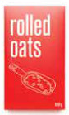 | Wholegrain, wholewheat flakes, wholegrain puffed cereals, porridge, wholewheat biscuits that meet the nutrient criteria* (e.g. Weet-Bix, Cheerios, Mini Wheats, Rolled Oats. |  | High in sugar or sodium or low in fibre varieties that do not meet nutrient criteria* (e.g. Coco Pops, Rice Bubbles, Fruit Loops)
Rice, grains, pasta  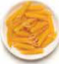 | Plain rice, pasta and noodles (like hokkien, rice noodles and vermicelli), polenta, couscous |  | 2 minutes noodles
Milk, yoghurt, custard and cheese  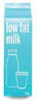 | Skim or reduced-fat milk  Low- or reduced-fat cheese  Low- or reduced-fat plain or fruit yoghurt  Custard without added confectionery.  Low fat soy drink, calcium added. | Full-fat milk,  Full-fat cheese  Full-fat plain or fruit yoghurt and custard without added confectionery  Frozen yoghurt and dairy desserts that meet the nutrient criteria * and milk as first ingredient  Low or reduced-fat ice cream with milk as the first ingredient- no chocolate coating
Food Group | Go!  Always on the menu  These foods are the best choice and should be most of your menu. | Slow -  Select Carefully  Chose less of these and keep the portion size small. | Stop!  Not on the menu  Do not provide these foods as part of the SNP.
Fruit   | All fresh fruit  Frozen fruit  Canned fruit in natural juice | Dried fruit/ Fruit leathers  must be 100% fruit and small serve size (<25g) | Canned fruit in syrup
Vegetables and legumes (beans)  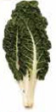 | All fresh vegetables  All frozen vegetables,  All dried or canned vegetables.  All legumes, e.g. chickpeas, lentils, kidney beans and baked beans, dried lentil patties and falafels including grilled and baked | Oven-baked potato products that meet the nutrient criteria* | Oven baked potato products that do not meet the nutrition criteria
Meat, fish, poultry and alternatives  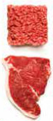  Remove fat from meat and skin from chicken before cooking | Unprocessed lean^ beef, chicken, lamb, pork, turkey and fish  Canned tuna, salmon and sardines  Eggs | Processed meat: burgers, nuggets, strips, balls, sausages, frankfurts, stews that meet the nutrient criteria*  Lean processed luncheon meats (e.g. Lean leg/shoulder ham, Fritz, devon, chicken loaf, free flow chicken, cured meat, bacon) that meet the nutrient criteria*  Chicken drumsticks and wings. | Processed or luncheon meats that do not meet the nutrition criteria

Food Group | Go!  Always on the menu  These foods are the best choice and should be most of your menu. | Slow -  Select Carefully  Chose less of these and keep the portion size small. | Stop!  Not on the menu  Do not provide these foods as part of the SNP.
Commercially-prepared savoury hot food items   | Rice, pasta, noodle, vegetable dishes that meet nutrient green criteria* | Pizza, pasta, rice, noodle dishes that meet amber nutrient criteria*  Savoury pastries and filled breads that meet amber nutrient criteria* | All deep-fried foods
Snack foods  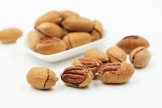 | Plain popcorn – no added salt, fat or sugar and plain dry biscuits.  Plain and savoury scones, pikelets and pancakes made with fortified flour and served with fruit (e.g. sultanas, banana)  Nutscheck your school policy to see if nuts are allowed (unsalted, unsweetened, un-roasted, dry roasted) | Flavoured dry biscuits, rice cakes, rice crackers, corn cakes that meet amber nutrient criteria*  Un-iced cakes, muffins, slices and sweet pastries that meet amber nutrient criteria*  Dip/cheese and biscuit packs that meet nutrient criteria | Iced cakes and slices, doughnuts, pastry items, croissants, cream-filled buns/cakes  All types of confectionery e.g. lollies, chocolate, chocolate spreads, icing, liquorice, soft lollies, choc chips, 100s and 1000s coatings, carob, yoghurt or carob coatings.
Spreads, dips and relishes  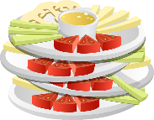  Use in small amounts | Low-fat and low-salt legume, dairy or vegetable-based dips or salsas that * meet nutrient criteria. Note examples and recipes below. | Peanut butter and other nut spreadcheck your school policy to see if nuts are allowed  Legume, dairy or vegetable based dips * meet nutrient criteria.  Reduced fat mayonnaise  Salsa and relishes  Yeast extract spreads (e.g. Vegemite) honey, golden syrup, jams  Fish, chicken, meat paste | Chocolate spreads  Full fat mayonnaise
Sauces    Must be low or reduced fat and salt products and use in small amounts |  | Reduced or low salt tomato, BBQ and soy sauce  Reduced or low salt tomato paste and gravy, satay, stock  Mustard and sweet chilli sauce  White sauce made with reduced fat dairy and margarine | Sauces/stocks/gravies that are not salt-reduced e.g. satay sauces.
 | Go!  Always on the menu  These foods are the best choice and should be most of your menu. | Slow -  Select Carefully  Chose less of these and keep the portion size small. | Stop!  Not on the menu  Do not provide these foods as part of the SNP.
Fats and oils  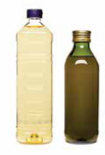  Use in small amounts |  | Polyunsaturated and monounsaturated oils and spreads: e.g. Sunflower, safflower, corn, soya bean, olive, vegetable and canola | Cream, coconut cream, coconut milk, coconut oil, butter, copha, ghee and lard
Pastry   |  | Filo or home-made margarine based pastry * | Puff and short-crust pastry
Drinks  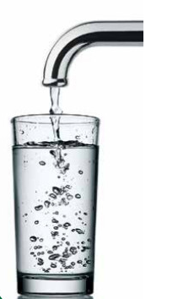 | Water  Plain mineral water  Plain sparkling water  Low or reduced-fat milk^: plain and flavoured up to 375mL (coffee flavour only in middle and senior school). | Full fat milk: plain and flavoured up to 375mL (coffee flavour only in middle and senior school).  Prepacked smoothies, liquid breakfast and yoghurt drinks (Milk must be listed as the first ingredient)  Full fat soy or plant based drinks with calcium added  Fruit and vegetable juice: 99-100% fruit or vegetable juice; no added sugar, serves of 250mL or less  Fruit ice blocks , fruit jelly desserts, ice crushes and slushies – at leas 99% fruit juice and no added sugar.  - Iced slushies and fruit jellies max 200ml  - Fruit ice blocks max 125mL serve | Soft drinks, iced tea, cordial, sports drinks, flavoured mineral water, energy drinks, sweetened waters.  Juice (< 99% juice or added sugar or > 250 ml serve size or contains de-ionised juice).  Slushies <99% Juice or > 200mL  Tea/coffee, coffee flavoured milks >375mL,  Coffee flavoured non milk products such as desserts  Energy drinks (any drink products containing guarana).  Soy or plant based drinks no added calcium  Products containing deionised juice  Jelly desserts, juice jellies, icy poles and fruit ice blocks (Less than 99% fruit juice or > 125 ml serve size),

Nutrient Criteria

Table 1 – Use to assess Hot food items and processed meats
Category | Nutrient Criteria
Category | Energy (kJ)  per 100g | Saturated fat (g) per 100g | Sodium (mg)  per 100g
Savoury pastries, filled breads, pizzas, oven-baked potato products, dim sims, spring rolls | 1000kJ or less | 5g or less | 400mg or less
Meat products and alternatives crumbed and not-crumbed (burgers, patties, strips, balls or nuggets), sausages, frankfurts and saveloys | 1000kJ or less | 5g or less | 450mg or less
Processed luncheon meats (fritz, devon, chicken loaf, free flow chicken products) and cured meats (for example: ham, bacon) | 1000kJ or less | 3g or less | 750mg or less
Pre-prepared meals based on core foods including rice and noodle dishes, sushi, pasta dishes, stews, casseroles and curries | greater than 1000kJ | greater than 5g | greater than 400mg
 | 1000kJ or less | 5g or less | 400mg or less
 | 750kJ or less | 3.5g or less | 300mg or less

Table 2 – Use to assess Snack food items

Category | Nutrient Criteria
Category | Energy (kJ)  per serve | Saturated fat (g)  per serve | Sodium (mg) per serve | Fibre (g)  per serve
Sweet snack food, bars and biscuits | 600kJ or less | 3g or less | - | 1g or more
Savoury snack food, biscuits, crisp breads and crisps  Energy must be 1800kJ or less per 100g | 600kJ or less | 2g or less | 200mg or less | -
Snack packs, dip and biscuit packs, cheese and biscuit packs | 500kJ or less | 5g or less | 300mg or less | -
Dairy based ice creams, frozen yoghurt, dairy dessert  Milk must be listed as first ingredient | 600kJ or less | 3g or less | - | -
Prepacked smoothies, liquid breakfast and yoghurt drinks  Milk must be listed as first ingredient | 900kJ or less | 3g or less
Un-iced cakes, muffins and sweet pastries | 900kJ or less | 3g or less | - | 1.5g or more

Table 3 – Sauces, dips and soups

Category | Nutrient Criteria
Category | Saturated fat (g) per 100g | Sodium (mg) per 100g
Pasta sauces and simmer sauces | 2g or less | 300mg or less
Dips (legume, diary, vegetable or salsa) | 2g or less | 750mg or less
Soups as prepared ready-to-eat (condensed, instant) | 2g or less | 300mg or less
Table 3 helps to decide which products are the healthier choice. If the food being assessed has less than or equal to the numbers specified in the saturated fat or sodium column, it is Go! - ALWAYS ON THE MENU. If it is over either of the thresholds, it is Slow - SELECT CAREFULLY.

Table 4 – Breakfast cereals
Nutrient Criteria
Sugar (g) per 100g | Fibre (g) per 100g | Saturated fat (g) per 100g | Sodium (mg)  per 100g
Cereal without added fruit, 20g or less  Cereal with added fruit, 25g or less | 5g or more | 2g or less | 600mg or less
Table 4 is for breakfast cereal. If the cereal being assessed has less than or equal to the numbers specified in the sugar, saturated fat or sodium column, and more than or equal to the number specified in the fibre column, it is Go! - ALWAYS ON THE MENU. If any criterion is not met –the cereal is categorised as Stop! - NOT ON THE MENU.

The breakfast cereals in this table have been assessed against the nutrient criteria. There are many other breakfast cereals available. If you want to serve a breakfast cereal that isn’t on this list, please make sure you check the nutrient criteria above to make sure you can serve that product.

CAN BE SERVED* | CANNOT BE SERVED*
All Bran (all varieties except Honey Almond)  Sultana Bran Buds  Sustain  Weetbix  Cheerios (low sugar, wholegrain, honey varieties)  Plus (all varieties)  Vita Wheats  Vita Brits  Guardian  Special K (including Nourish variety)  Rolled Oats (plain, all brands) | Corn Flakes (including gluten free)  Rice Bubbles (including Multigrain shapes)  Coco pops (all varieties)  Sultana Bran  Nutrigrain  Milo cereal  Nesquick cereal  Fruit loops

*Assessment of these breakfast cereals was correct at time of writing (January 2018) but products change over time so if you’re not sure, check with a nutritionist or use the nutrient criteria tables.

Steps to assessing an item with a Nutrient Information Panel

- Find the nutrition information panel on the food you wish to assess. A nutrition information panel will look like this:

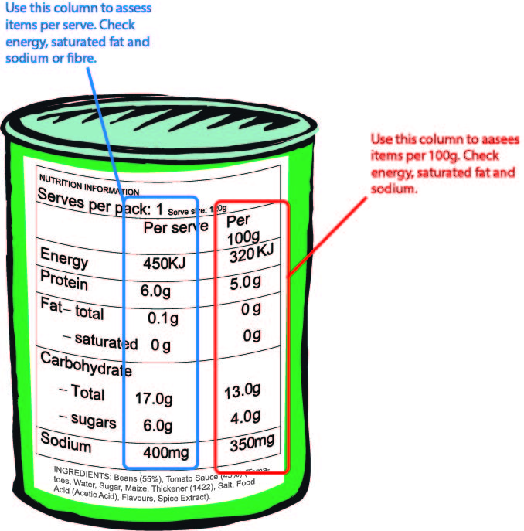

- Compare to the “Nutrient Criteria” tables on Page 8.

- Compare the nutrients “per 100g” or “per serve” in the food against the numbers in the “Nutrient Criteria” table.

- If the food does not meet any one of the criterion, then the food fits within the Stop! - NOT ON THE MENU category and must not be provided as part of the school nutrition project (SNP).

Please contact your local Public Health Nutritionist if you or your School Nutrition Project (SNP) staff would like training on reading food labels.

Steps to assessing an item with no Nutrient Information Panel
- Identify major ingredients and minor ingredients
- Major ingredients make up most of a food. Most ingredients are ‘major’ except if they are added in very small amounts.

- Minor ingredients are only a small part of the item. Some examples of minor ingredients are dressings, sauces, spreads, garnishes and oils.

- Decide if major and minor ingredients are Go!, Slow or Stop (use tables on pages 8 & 9).

- Use the information in the chart or table below to decide whether the overall food or drink is in the Go, Slow or Stop category.

Example: Crumbed chicken-patty burger, an oven-baked crumbed chicken patty:
- Major ingredients: bread bun, oven-baked chicken patty, onion and lettuce
- Minor ingredients: mayonnaise (regular-fat)
Food item: | Crumbed chicken-patty burger
 |  | Go | Slow | Stop
Major ingredients | Bread bun  Oven-baked chicken patty  Onion  Lettuce | X  X  X | X |  | Overall:  Slow – select carefully
Minor ingredients | Mayonnaise (regular fat) |  | X |  | Overall:  Slow – select carefully
Acknowledgement: These steps were developed based on the Victorian Healthy Choices: food and drink classification guide.
Menu Planning
When planning your SNP menu offer a variety of foods to make sure children have the nutrients their bodies need. Offer:

- Different types of hot and cold meals and snacks (not the same thing every day)

- Every day include
  - Lean meat (fish, chicken, red meat), eggs or legumes;
  - vegetables;
  - grain (cereal);
  - dairy products and
  - fruit .

- Serving sizes should be enough for a school aged child. Speak to your local nutritionist for help with serve sizes.

- Water and plain, reduced fat milk are the best drinks for the SNP.
The following table has some menu ideas for your SNP:
Breakfast | Cereal* with milk  Toast (plain or fruit bread) with thinly spread margarine or peanut butter check your school policy to see if nuts are allowed  Hot dish: Boiled/scrambled egg on toast OR Baked Beans on toast  Fruit salad and yoghurt
Lunch | Sandwiches/wraps  Make sure that all sandwiches/wraps are made with fresh fillings.  - Choose wholegrain, multi-grain or wholemeal bread.  - Add a healthy protein  - Add plenty of vegetables.  See page 15 for suggested sandwich fillings. | Healthy protein for sandwiches  Lean meat: roast meats with no visible fat or chicken with no skin.  Fish: tuna, salmon, sardines (tinned or fresh)  Egg: hard boiled, mashed, sliced, curried  Baked beans  Cheese, preferably low or reduced fat  Vegetable and fruit ideas for sandwiches  Salad: lettuce, carrot, tomato, sprouts, cucumber, beetroot, corn, pineapple, beetroot  Creamed corn  Sultanas
Lunch | Hot Foods  - Make that all hot meals have vegetables with them.  - Use minimal oil when cooking.  - Choose lean cuts of meat.  See pages 18-21 for recipes and suggested cookbooks. | Hot food ideas  Spaghetti Bolognaise  Fried Rice  Stew (kangaroo; beef or lamb) with vegetables  Oven-baked fish served with vegetables  Curry (chicken or beef) with vegetables and served with rice  Stir-fry meat with vegetables and served with rice  Soup served with a multi-grain or wholemeal bread roll  Shepherd’s Pie  Lasagne  Pasta bake  Macaroni Cheese with tuna and vegetables  Mini pizzas (using English Muffins or Pita Breads) topped with vegetables, lean meat and cheese.  Baked potatoes topped with kidney beans, vegetables, mince and cheese.
Snacks | Fresh whole fruits  Fruit salads/kebabs  Vegetable sticks with a low-fat dip  Corn cobs  Yoghurt  Cheese sticks/ mini cheese rolls  Dried fruit and nut packs check your school policy to see if nuts are allowed  Tinned fruit with yoghurt |  | Cheese and crackers  Boiled eggs  Popcorn  Raisin toast with low-fat cream cheese  Baked bean jaffles  Muffins made with pureed apples, mashed banana or berries and wholemeal flour.
Drinks | Water (plain)  Milk (preferably skim or reduced fat). Plain milk is best.  If adding a flavour to milk, at most add to 2 heaped teaspoons of powder or 2 teaspoons of topping/ syrup to 250mL milk.
* Products will need to be assessed against the nutrition criteria – Refer to page 8 and page 9

Healthy Dip Ideas
Serve these dips with vegie sticks or healthy crackers*.
Make veggie sticks from carrot, zucchini, cucumber, capsicum, broccoli or cauliflower.

Salmon Dip
Ingredients:
210g can salmon, drained
250g reduced fat cream cheese
Juice of ½ a lemon

Method:
- Mix well.

Spinach Dip
Ingredients:
½ packet frozen spinach
250g reduced fat cream cheese
1 tbsp lemon juice

Method:
- Defrost spinach, squeeze out water and cut up as small as possible. (Or you can process all ingredients in a blender or food processor.)
- Mix with other ingredients.

Beetroot Dip
Ingredients:
425g can beetroot, drained
250g reduced fat cream cheese
1tbsp lemon juice

Method:
- Chop beetroot as small as possible or grate. (Or you can process all ingredients in a blender or food processor.)
- Mix with other ingredients.

Simple Guacamole
Ingredients:
2 ripe avocadoes
Juice of ½ a lemon

Method:
- Mash avocadoes well with a fork until soft and smooth.
- Mix in lemon juice.

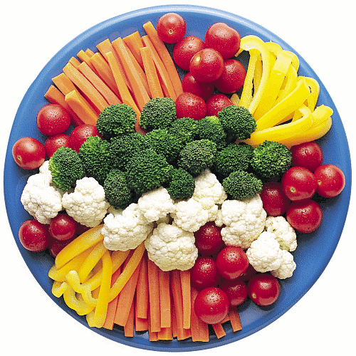
Sandwich Ideas

Try some of these filling suggestions:
- Lean meat + salad
- Tuna, salmon or sardines + corn or salad
- Beef + pickles + tomato
- Sardines or herring + tomato
- Egg (mashed, curried or sliced) + lettuce
- Lean ham* + cheese + tomato
- Peanut buttercheck your school policy to see if nuts are allowed + grated carrot + sultanas or salad
- Cheese + grated carrot + sultanas
- Raisin bread with banana + sultanas + peanut buttercheck your school policy to see if nuts are allowed
- Yeast extract spread (e.g. Vegemite, Marmite or Promite) + cheese
- Cheese stick wrapped in bread with a yeast extract spread
- Chicken (skin removed) + lettuce + mayonnaise

Try these fillings toasted:
- Baked beans + cheese
- Canned spaghetti + cheese
- Savoury mince + vegetables
- Lean ham* + cheese + tomato
- Lean ham* + cheese + pineapple
- Lean ham* + cheese
- Lean ham* + cheese + sweet corn
- Sardines + tomato
- Tomato + cheese
- Egg + vegetables
- Tuna + tomato
- Stew + egg
- Grated vegetables + cheese
- Corn kernels + tomato + skinless chicken
- Apple (canned or stewed) + sultanas + cinnamon

Tips for making great sandwiches!
Use high fibre white, wholemeal, multigrain, raisin or fruit bread.
Only use a thin scrape of margarine on bread.
1 loaf of bread usually makes 10 sandwiches.

Example of a 4 week menu
WEEKS | MEAL | MONDAY | TUESDAY | WEDNESDAY | THURSDAY | FRIDAY
WEEK 1 | BREAKFAST | Cereal with low fat milk  Reduced salt baked beans on toast | Cereal with low fat milk  Boiled eggs on toast | Cereal with low fat milk  Raisin toast and spread | Cereal with low fat milk  Reduced salt spaghetti on toast | Cereal with low fat milk  Reduced salt baked beans on toast
WEEK 1 | MORNING TEA | Cheese and water crackers | Vegetable sticks with beetroot dip | Tinned fruit | Mini fruit muffin | Yoghurt cup
WEEK 1 | LUNCH | Spaghetti bolognaise with added vegies and pasta  Fresh fruit or fruit salad | Apricot chicken and rice and steamed vegies  Fresh fruit or fruit salad | Mixed sandwiches (using ideas on page 15)  Fresh fruit or fruit salad | Chicken and salad sandwiches  Fresh fruit or fruit salad | Beef stew with added vegies and rice  Fresh fruit or fruit salad
WEEK 1 | AFTERNOON TEA | Yoghurt cup | Fruit pikelets | Boiled eggs | Corn cobs | Cheese melts (English muffins with reduced fat cheese)
WEEK 2 | BREAKFAST | Cereal with low fat milk  Reduced salt baked beans on toast | Cereal with low fat milk  Boiled eggs on toast | Cereal with low fat milk  Raisin toast and spread | Cereal with low fat milk  Scrambled eggs on toast | Cereal with low fat milk  Reduced salt baked beans on toast
WEEK 2 | MORNING TEA | Fruit scones | Air popped popcorn | Cheese melts (English muffins with reduced fat cheese) | Yoghurt cup | Corn cobs
WEEK 2 | LUNCH | Corned beef* and salad sandwiches  Whole fresh fruit | Shepherd’s pie with added vegies  Fresh fruit or fruit salad | Chicken and salad burgers  Whole fresh fruit | Tuna Bake with peas and corn  Fresh fruit or fruit salad | Chili con carne baked potatoes with shredded cheese and salad  Whole fresh fruit
WEEK 2 | AFTERNOON TEA | Cheese and crackers | Baked bean jaffles | Raisin toast with low-fat cream cheese | Spaghetti jaffles | Vegie sticks with simple guacamole

WEEKS | MEAL | MONDAY | TUESDAY | WEDNESDAY | THURSDAY | FRIDAY
WEEK 3 | BREAKFAST | Cereal with low fat milk  Reduced salt baked beans on toast | Cereal with low fat milk  Boiled eggs on toast | Cereal with low fat milk  Raisin toast and spread | Cereal with low fat milk  Scrambled eggs on toast | Cereal with low fat milk  Reduced salt baked beans on toast
WEEK 3 | MORNING TEA | Apple muffins | Banana muffins | Vegetable sticks with salmon dip | Vegetable sticks with beetroot dip | Fruity pikelets
WEEK 3 | LUNCH | Rissoles with gravy, mixed vegetables and mashed potato  Fresh fruit or fruit salad | Apricot chicken and rice with steamed vegies  Fresh fruit or fruit salad | Lasagne and salad  Fresh fruit or fruit salad | Roast beef and gravy rolls with salad  Fresh fruit or fruit salad | Kangaroo & vegetable stir-fry with rice  Fresh fruit or fruit salad
WEEK 3 | AFTERNOON TEA | Raisin toast with low-fat cream cheese | Cheese and crackers | Boiled eggs | Fruity pikelets | Tinned fruit with yoghurt
WEEK 4 | BREAKFAST | Cereal with low fat milk  Reduced salt baked beans on toast | Cereal with low fat milk  Boiled eggs on toast | Cereal with low fat milk  Raisin toast and spread | Cereal with low fat milk  Scrambled eggs on toast | Cereal with low fat milk  Reduced salt baked beans on toast
 | MORNING TEA | Vegetable sticks with spinach dip | Cheese melts (English muffins with reduced fat cheese) | Yoghurt cup | Tinned fruit with yoghurt | Corn cobs
 | LUNCH | Mixed sandwiches (using ideas on page 15)  Fresh fruit or fruit salad | Chicken noodle and sweet corn soup with a bread roll  Fresh fruit or fruit salad | Easy quiche with lettuce and tomato  Fresh fruit or fruit salad | Corned beef* with boiled potatoes, vegetables & white sauce  Fresh fruit or fruit salad | Tuna and pasta salad with a bread roll  Fresh fruit or fruit salad
 | AFTERNOON TEA | Air popped popcorn | Raisin toast with low-fat cream cheese | Fruity pikelets | Boiled eggs | Cheese and crackers

Recipe Ideas

Spaghetti Bolognaise
Serves 30 people
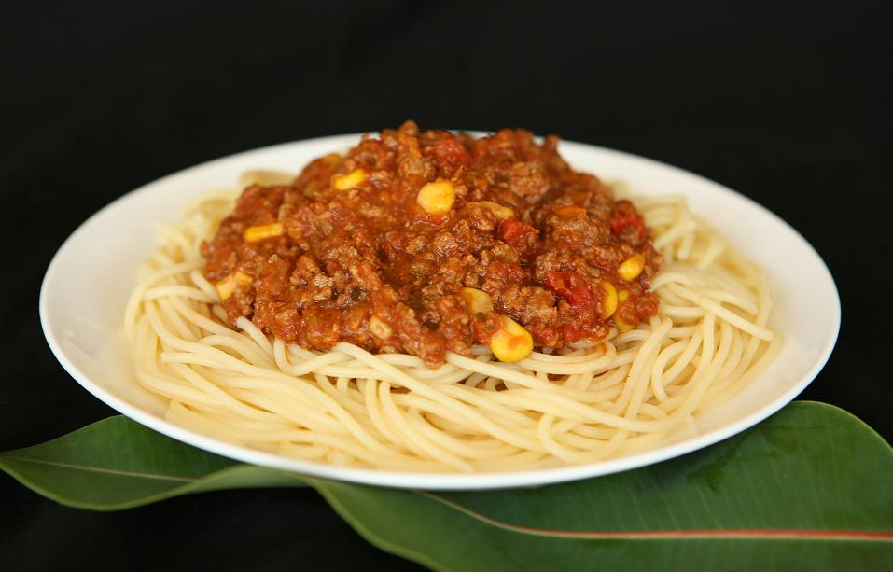

Ingredients:
3 kg Beef Mince
1 kg Onion, peeled and chopped
1 kg Carrots, peeled and chopped
1 kg Capsicum, chopped
3 x 420g tin Corn kernels
3 x 800g tin Chopped Tomatoes
3 tablespoons chopped Garlic
6 tablespoons Tomato paste
3 tablespoons Vegemite
3 tablespoons mixed Herbs
5 Bay leaves (optional)
4 tablespoons Vegetable Oil
Water
Pasta, Rice or Bread

Methods:
- Chop vegetables and gather all ingredients.
- Heat the oil in a pot, add Mince and fry until brown.
- Place Onions, Carrots, Capsicum and Corn into the pot and stir.
- Add the Tomatoes, Garlic, Tomato paste, Vegemite, mixed Herbs, Bay leaves and stir.
- Add some water just to cover the top of the Mince and simmer on low heat for 1 hour.
- Serve with pasta, rice or bread.

Easy Quiche
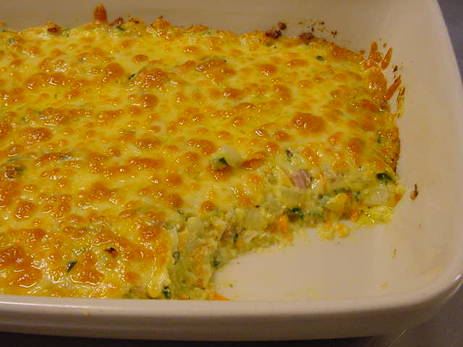
Makes 2 quiches to serve 20

Ingredients:
400g lean Ham*, cut up small
12 Eggs
5 cups Milk, reduced fat
½ cup Margarine, melted
2 cups Plain flour
2 teaspoons chopped Garlic
Herbs to taste
Pepper to taste
4 cups Carrot, grated
4 Onions, chopped
20 leaves Spinach, chopped or 3 Zucchinis, grated

Methods:
- Set oven to 180°C.
- Chop Onion, grate Carrot and cut up Spinach (or grate Zucchini).
- Lightly grease dishes.
- Place Ham in bottom of dish.
- Beat Eggs in bowl and add Milk, Margarine, Flour, Garlic, Herbs and Pepper.
- Add Carrot, Onion, Spinach (or Zucchini) and grated Cheese into a bowl.
- Pour into oven dishes. Cook for 50 minutes or until set.

Chicken Noodle and Sweet Corn Soup
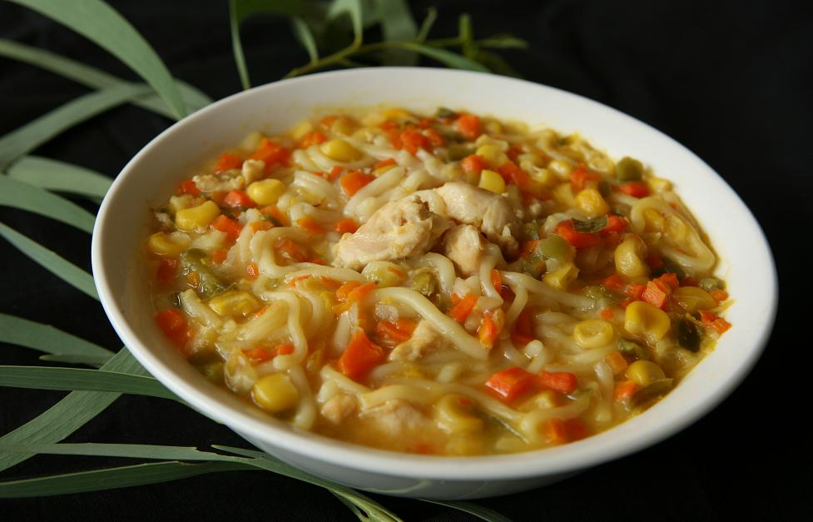
Serves 30 people

Ingredients:
3 kg Chicken (Breast or Thigh fillet), skin removed
1 kg Carrots, peeled and chopped
500g (approx. 3) Capsicum, chopped
1 kg Onions, chopped
15 L Water
6 x 420g Creamed Corn
6 x 420g Corn Kernels
3 kg Noodles
4 tablespoon Vegetable Oil

Methods:
- Chop vegetables and gather all ingredients.
- Heat the oil in a pot and fry Onions, Carrots and Capsicum until soft.
- Cut the Chicken into bite size pieces and add to the pot, stir until brown.
- Add water to the pot and bring to the boil. Then turn down the heat to low and simmer for 30-45 minutes.
- Place Creamed Corn, Corn Kernels and Noodles into the pot. Stir.
- Serve when Noodles are soft.

Shepherd’s Pie4
Serves 30 people
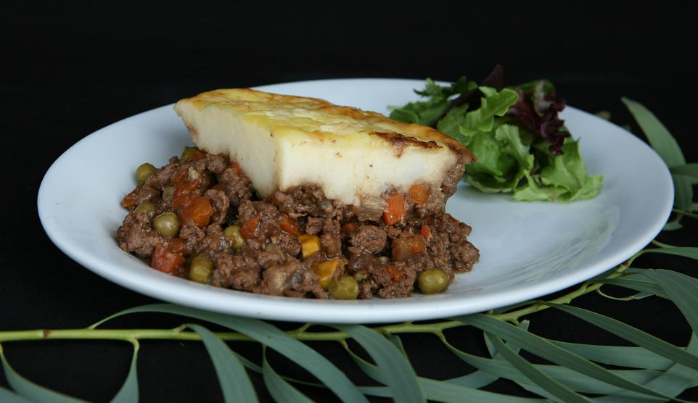

Ingredients:
3 kg Beef Mince
3 kg Potatoes
1 kg Onions
6 Eggs, raw
1 x 2kg bag of frozen mixed vegetables
6 tablespoons Worcestershire Sauce
6 tablespoons Gravy mix
3 cups Cheese, grated
4 tablespoons Vegetable Oil
Water

Methods:
- Peel and boil the Potatoes until they are soft. Mash Potatoes and mix through Eggs.
- Chop Onions and gather all ingredients.
- Heat the Oil in a pot. Add Mince and Onion and fry until brown.
- Add vegetables, Worcestershire Sauce, Gravy mix and water to cover Mince. Bring to the boil.
- Place Mince mixture into a deep baking tin and spread mashed Potato over the top. Sprinkle with Cheese.
- Bake in the oven at 180°C for 45 minutes or until top is golden brown.

Resources

Here is a list of suggested recipe books and supporting resources:

- Kukumbat gudwan daga: ‘Really cooking good food’. A healthy cookbook with recipes that feed 10 or more people. Developed by the Women’s Centres of Manyallaluk, Gulin Gulin and Wugularr in partnerships with The Fred Hollows Foundation. Download Healthy Food Recipes - Thumbs Up Foundation. The cookbook can be ordered through Batchelor Press phone 8939 7352.

- Deadly Tucker and More Deadly Tucker Cookbooks. Developed by North Metropolitan Area Health Service, Population Health, Department of Health, Western Australia. Each edition features low cost, easy to prepare recipes, including soups, main dishes, salads and vegetables and desserts; each recipe includes step-by-step photographs in full colour and all recipes rated for suitability for people with diabetes.
- Deadly Tucker
Deadly Tucker Recipe Booklets - Superhero Foods HQ by Foodbank WA download
More Deadly Tucker
MDT-Cookbook-Order-Form.pdf (health.wa.gov.au) order

- Living Strong – Healthy Lifestyle Cookbook. Developed by Queensland Health. This cookbook provides a variety of healthy recipe ideas and some traditional cooking for you and your family to enjoy.
Living strong: healthy lifestyle cookbook - Living strong healthy lifestyle cookbook - Resources - Promote and practice - Australian Indigenous HealthInfoNet (ecu.edu.au)

- Flour Drum Stove cookbook. Recipes for up to 10 people that can be prepared in a wok using a flour drum stove or regular cook top. http://digitallibrary.health.nt.gov.au/prodjspui/handle/10137/241

- Tastes Good, Is Good. Tasty tucker for 10 or more people. http://digitallibrary.health.nt.gov.au/prodjspui/handle/10137/129

- Department of Education (DoE) – School Nutrition and Healthy Eating Policy. Developed by Northern Territory Departments of Education and Health. The link also provides a suite of supporting materials including healthy fundraising ideas and alternatives to sausage sizzles https://education.nt.gov.au/education/policies/school-nutrition-and-healthy-eating

Acknowledgement

Images under Sandwich Ideas and Recipe Ideas reproduced with kind permission from The Fred Hollows Foundation www.hollows.org Kukumbat gudwan daga (Really cooking Good Food)

Appendix 1 - The Aboriginal and Torres Strait Islander Guide to Healthy Eating

Adapted with permission from the Barkly Shire School Nutrition Program 2011 * These products will need to be assessed against the nutrition criteria – refer to page 8 and page 9. Most corned beef falls outside the Nutrition Criteria, however selecting a lean cut of beef will ensure it falls below the saturated fat criteria and double boiling the beef should reduce the sodium content.
Kukumbat gudwan daga: ‘Really cooking good food’ recipe book, page 6.
Tastes Good, Is Good, page 10.
Kukumbat gudwan daga: ‘Really cooking good food’ recipe book, page 12.

