NT Health, Health Advisory Committee Terms of Reference

Document title | NT Health, Health Advisory Committee Terms of Reference
Contact details | NT Health
Approved by | NT Health Leadership Committee
Date approved | April 2022
Document review | Annually
TRM number | EDOC2022/149028

Version | Date | Author | Changes made
1.1 | 17 March 2022 | Stephanie Schreiner | first draft
2.0 | 17 May 2022 | Stephanie Schreiner | NT HLC endorsed
2.1 | 20 June 2022 |  | Cabinet Office endorsed
2.2 | 21 September 2022 | Stephanie Schreiner | NT Health Governance Structure included
3.0 | 24 March 2023 | Stephanie Schreiner | Annual review
4.0 | 14 June 2024 | Karina Eastway | Annual review  NT Health Governance Structure updated  Addition of ‘financial’ year at 7.2

Acronyms | Full form
NT | Northern Territory
NTH HAC | NT Health, Health Advisory Committee
RCEG | Regional Community Engagement Group

Contents
1. Background 4
2. Governance 4
3. Purpose and Role 5
4. Functions 5
5. Responsibilities 5
6. Membership 5
6.1. Composition 5
6.2. Chair 6
6.3. Member Responsibilities 8
6.4. Remuneration / Sitting Fees 8
6.5. Secretariat 8
6.6. Proxies 8
6.7. Frequency of Meetings and Quorum 8
6.8. Recording of Meetings 8
6.9. Regional Consumer Engagement Groups 8
7. Confidentiality 8
8. Conflict of Interest 8
9. Review 9

Background
The Northern Territory Health, Health Advisory Committee (NTH HAC) is a consumer representative committee providing advice to the Chief Executive through the Northern Territory Health Leadership Committee (NTHLC).
The Health Service Act 2021 (the Act) established a single integrated entity responsible for the delivery of health services, as defined by section 9 of the Act.
The System Manager is the CEO of the Agency (NT Health) in accordance with section 15 of the Act.
The functions and powers of the System Manager are outlined in section 16 of the Act, and include ensuring there are appropriate mechanisms for consultation across the regions in the Northern Territory.

Governance
The System Manager can establish advisory panels under section 21 of the Act with the powers necessary to perform this function.
The NTH HAC is a consumer representative committee providing advice to the System Manager (the Chief Executive of the Department of Health) through the NT Health Leadership Committee.
The NTH HAC Terms of Reference are complemented by the Norther Territory Public Sector Code of Conduct.

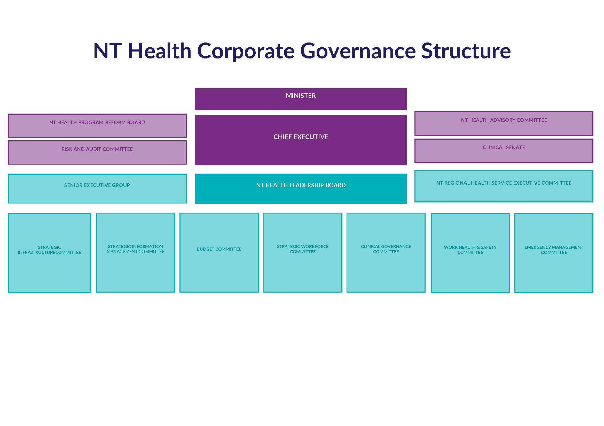

Purpose and Role
The purpose and role of NTH HAC is to:
- ensure the voices of health consumers, carers and the community are heard and that their needs are taken into account in decisions related to healthcare policies, programs and services;
- serve as an essential advisory group that helps to ensure that healthcare in the NT is inclusive, accessible and responsive to the needs of all members of the community;
- support NT Health’s vision of Great health for all Territorians and the central values of being Safe, Responsive and Kind; and
- support a health service-wide approach to achieving compliance with National Safety and Quality Health Service, Standard 2: Partnering with Consumers.

Functions
Section 21 of the Act states that the function of an advisory panel is to give the System Manager or the Executive the advice the System Manager requests.
NTH HAC supports the high-level decision making processes of NT Health (inclusive of the Department of Health and NT Regional Health Services) through provision of advice, information to, consultation with, and advocacy on behalf of the people and communities served by NT Health.
NTH HAC will provide a Territory-wide focus to ensure appropriate and necessary community input and engagement in health service planning and responsiveness of NT Health to the needs of Territorians.
NTH HAC will also facilitate the identification and consideration of community priorities in the development and implementation of the strategic goals and directions of NT Health.

Responsibilities
Each member is responsible for:
- attending meetings and participate in work plan activities by contributing specialist knowledge, expertise and providing consumer, carer and community perspectives;
- having the capacity to reflect on and present consumer, carer and community issues rather than focusing on personal concerns or individual issues;
- being proactively involved and working collaboratively with other committee members;
- ensuring the best interests of the users of the health service are the main consideration in all decisions and actions;
- striving to provide access to safe, high-quality health services in the NT;
- striving to achieve health equity for the diverse, disadvantaged, isolated, and marginalised consumers, carers and communities.

Membership
NTH HAC members are appointed by the Chief Executive (System Manager) from across the Territory to ensure appropriate and necessary local consumer input and engagement in health services planning and responsiveness to local needs.

Composition
Section 21(2)(a) of the Act provides the composition of an advisory panel, which is to consist of members appointed by the System Manager that the System Manager considers appropriate, and a Chair appointed by the System Manager.
The NTH HAC will be comprised of a minimum of eight (8) and a maximum of twelve (12) consumer members.
Appointment to the NTH HAC will ensure membership reflects a sufficient mix of gender, background, skills and expertise which includes individuals with one or more of the following characteristics:
  - Health care consumer
  - Carer
  - Culturally and linguistically diverse background
  - Minimum of three (3) members who identify as either Aboriginal or Torres Strait Islander
  - Representation from each of the five (5) health service regions (Top End, Big Rivers, East Arnhem, Barkly and Central Australia).
- Exclude current employees of NT Health, the Commonwealth Department of Health, or the NT Health Primary Health Network.
- Support members being appointed for an initial term of up to three years with potential for re-appointment for a single three year term.
- Ensure short extensions of appointment for periods of up to three months are considered by the Chief Executive for members whose terms are expiring.
Members may resign their position at any time by providing written advice to the Chief Executive directly or through the Chair.

Chair
Following consultation with the membership, a Chairperson and Deputy Chairperson will be appointed by the Chief Executive from the members. Where possible, either the Chairperson or Deputy Chairperson will identify as Aboriginal and/or Torres Strait Islander. The Deputy Chair will preside over meetings when the Chair is unavailable.
The Chairperson will;
- work within the NTH HAC Terms of Reference to promote and role model the NT Health vision and values;
- welcoming members and running the meeting to an agreed agenda;
- giving everyone the opportunity to speak, ensuring all members feel they have equal say and that their opinions are valued;
- ensure the roles and responsibilities of all members, as set out in the Terms of Reference, are fulfilled;
- encourage input from members that is diverse and offers creative ideas and solutions to health and service issues; and
- Seeking feedback at the end of every meeting on how successful it was.

Regional Consumer Engagement Groups
Regional Community Engagement Groups (RCEGs) are the regional consumer groups established within each of the five identified health service delivery regions of the Northern Territory (Top End, East Arnhem, Big Rivers, Barkly and Central Australia) to provide a consumer perspective on health service planning and the provision of health services in their local region.
Each NTH HAC member may also be a member of their respective RCEG. Consumer engagement enhances local input into system-wide responses and improves coordination and communication between the community and the health system; RCEGs provide local participation and aim to contribute to more effective planning and delivery of health services reflective of the needs of each community.

Responsibility of Regional Executive Directors
Regional Executive Directors are responsible for;
- the direct management, coordination and maintenance of their RCEG;
- providing support, advice and a contact point for the RCEG members; and
- ensuring the RCEG reporting requirements are met and communicated.

Responsibility of NTH HAC RCEG members
NTH HAC RCEG members are responsible for;
- regular attendance at RCEG meetings to inform the group about updates at the NT Health level;
- engaging with RCEGs to both gain and share information and an understanding of the regional health and service issues important to consumers, carers and the community; and
- assisting RCEGs to meet their role and responsibilities and work plan priorities.

Accountability and Reporting

Work Plans

Within the first three months of each year, a draft work plan for the coming 12 months will be developed. The work plan will identify how NTH HAC aims to undertake its role and the support the needs of that role. This work plan will be provided to the Chief Executive through the NTHLC.

The work plan will include simple and relevant evaluation criteria to enable NTH HAC to assess and gain feedback on its progress and areas to build upon including;
- key regional health issues;
- communication strategies; and
- achievements in relation to consumer input into health service improvement.

Annual Reporting
NTH HAC is to submit an annual update report (for the previous financial year) to the Chief Executive through the NTHLC for inclusion in the NT Health Annual Report.
Annual reports should be brief and outline the following;
- Key priorities, activities, and achievements;
- Regional health issues and opportunities;
- Lessons learnt and future plans.

Meeting and Communication Procedures

Frequency of Meetings and Quorum
- The NTH HAC will meet quarterly.
- One or more special meetings may be held to meet specific responsibilities.
- The Chair must call an out-of-session meeting if requested by the Chief Executive.
- A quorum is deemed as the majority of committee members (half full members plus one).
- Decisions will be made by consensus or majority view rather than formal vote. Where there is no majority view, this will be recorded as a result, in place of a decision.
- Committee members must attend a minimum of three (3) meetings in the twelve month period. Attendance may be in person or via teleconference (Microsoft Teams). Failure of a member to attend a minimum of three meetings per annum may result in the Chair recommending termination of appointment to the Chief Executive.
- A Chief Executive approved member of the NTHLC will attend all or part of each meeting and will participate as an ex-officio member and act as the Executive Sponsor. If the Executive Sponsor is unable to attend, the Chief Executive may send a proxy and will notify the Chair of the proxy arrangements prior to the meeting.
- The Chief Executive will attend the NTH HAC meetings from time to time as available.

Secretariat
The NTH HAC Secretariat will be provided by the Office of the Chief Executive. This includes;
- Supporting the committee’s efficient operations, including; scheduling of meetings, preparation of agendas, maintaining an actions and decisions register, assisting in work planning and evaluation activities, reimbursing members;
- Helping to develop community networks;
- Recruiting committee members.

Agenda and Minutes
Agenda items will be requested three weeks prior to meetings. Meeting papers will be circulated by Secretariat to all members in a timely manner prior to meetings.
Minutes in the form of key issues and actions will be recorded for each meeting and circulated to all members for information and action as required.

Proxies
Proxies are not an option for this committee and only member attendance is suitable.

Confidentiality
- Information obtained and used by the Committee is subject to the requirements under the NT Information Act 2002 and to the information release, storage and security guidelines applicable to NT Health.
- Confidentiality agreements will be signed by each member at the commencement of their term of membership.
- Members must not use or disclose any information obtained by NTH HAC except as part of meeting committee responsibilities, or unless expressly agreed by the Chief Executive.
- The Chair will advise of confidential items as they arise. Members and guest speakers are also required to clearly indicate if any information disclosed is confidential. In such circumstances, all members acknowledge their responsibility to maintain the confidentiality of associated disclosed information.

Conflict of Interest
- Any real, potential or perceived conflicts of interest should be declared at the commencement of each meeting, or as they arise. Members will provide annual written declarations to the committee through the Chair to the Chief Executive declaring any material personal interests they many have in relation to their responsibilities.
- At the commencement of each committee meeting members are required to declare any material personal interests that may apply to specific matters on the meeting agenda.
- The Chair will decide the course of action to be taken and a member may be required take absence from the meeting during discussion of an agenda item.
- The Northern Territory Public Service Code of Conduct provides practical guidelines on the use of information by public sector officers and services as a useful guide for board members.

Remuneration / Sitting Fees
NTH HAC members who are non-NTG employees will be remunerated in line with the current Classification Structure Determination (CSD) signed by the Administrator of the NT. NT Government employees are not eligible for remuneration but are entitled to reimbursement of travel and other expenses (Part 3 CSD). Payment will be made by electronic funds transfer into a nominated back account and superannuation will be paid to the member’s nominated superannuation fund, when applicable.
All committee members are entitled to reimbursement for an NT Working with Children Clearance (or renewal) and National Police Clearance (criminal history check).
Claims for reimbursement including receipts must be submitted to the Secretariat no later than seven (7) business days after a meeting. For taxation purposes, committee members must keep written evidence for five (5) years from the date of tax return lodgement. Reimbursements for expenses received by the Secretariat will be processed through Accounts Payable for payment into the nominated back account.

Review
The Chief Executive will undertake an annual review of the performance of the NTH HAC to ensure it is operating efficiently, effectively and appropriately in accordance with these Terms of Reference.
NTH HAC may review the Terms of Reference and/or membership with any suggestions to be formally approved by the Chief Executive.

