NT Health, Regional Community Engagement Group Terms of Reference

Document title | NT Health, Regional Community Engagement Group Terms of Reference
Contact details | NT Health
Approved by | NT Health Leadership Committee
Date approved | XX
Document review | Annually
TRM number | EDOC2022/391998

Version | Date | Author | Changes made
1.1 | 21 September 2022 | Stephanie Schreiner | first draft

Acronyms | Full form
NT | Northern Territory
NTH HAC | NT Health, Health Advisory Committee
HSA | Health Services Act 2021
RCEG | Regional Community Engagement Group

Contents
1. Background 4
2. Governance 4
3. Purpose and Role 5
4. Responsibilities 6
5. Membership 6
5.1. Chair 6
5.2. Member Responsibilities 7
5.3. Remuneration / Sitting Fees 7
5.4. Secretariat 7
5.5. Proxies 7
5.6. Frequency of Meetings and Quorum 7
5.7. Recording of Meetings 8
6. Confidentiality 8
7. Conflict of Interest 8
8. Review 9

Background
Regional Community Engagement Groups (RCEGs) are the advisory bodies established within identified health service delivery regions to provide an avenue for consumers, carers and communities to present a consumer perspective on the provision of health services in their local region.

Governance
RCEGs report to the Regional Executive Directors, providing a nexus with the System Manager through the Northern Territory Health, Health Advisory Committee (NTH HAC) via the provision of meeting minutes and elevation of significant issues for deliberation and advice.
The System Manager is the CEO of the Agency (NT Health) in accordance with section 15 of the Act.
The functions and powers of the System Manager are outlined in section 16 of the Act, and include ensuring there are appropriate mechanisms for consumer consultation across all regions in the Northern Territory.
The NTH HAC is the community representative committee providing advice to the Chief Executive through the Northern Territory Health Leadership Committee (NTHLC).
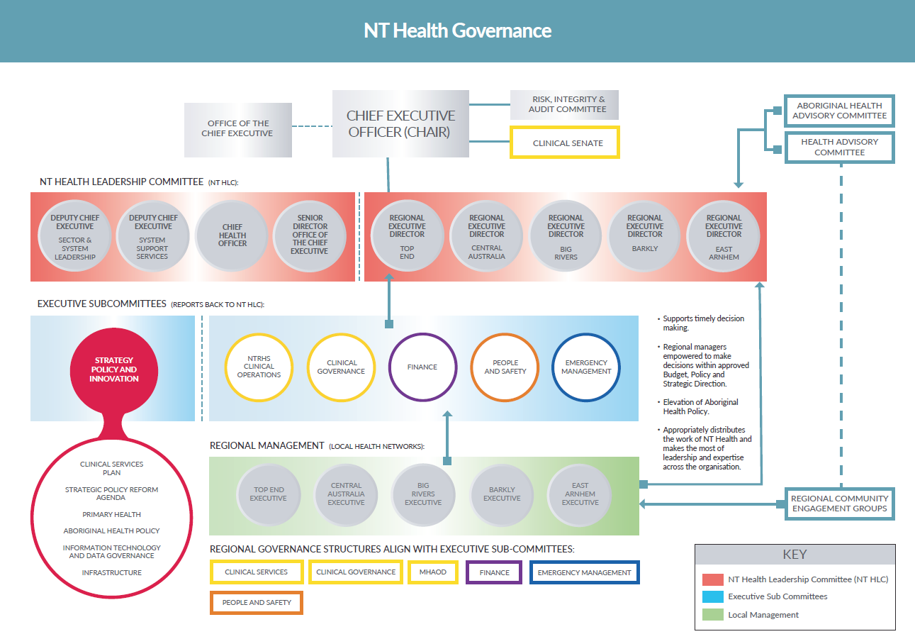

Purpose and Role
The role of the RCEGs is to:
- Identify key regional health service issues that members will advocate and provide advice on;
- Provide advice on other health service issues from a regional perspective
- Create forums for raising health care issues, care coordination and innovative ideas for service delivery for people in their regions;
- Promote communications between the regions, the community and the NTH HAC;
- Provide consumer/carer input on activities, policies, plans and projects at the individual, program, organisation and system levels in their region;
- Suggest and support further opportunities for consumer engagement that will promote health service improvements in the regions; and
- Work constructively to assist in addressing key regional health service issues.

RCEG members will advocate on behalf of the diverse health care users in the region, and are responsible for:
- Gathering the views of the residents/community they represent through their networks;
- Fairly representing the views of the residents/community; and
- Providing feedback after meetings to members of the community, as agreed by the RCEG.

RCEGs support NT Health’s core purpose to deliver better health for all Territorians and the central values of diversity, ethical practice, respect and courage, and in line with the National Safety and Quality Health Service Standards, Standard 2: Partnering with Consumers.
Partnering With Consumers:
The health service
- Involves consumers in partnerships in the governance of, and to design, measure and evaluate health care; and
- Has processes so that the consumers involved in these partnerships reflect the diversity of consumers who use the service or, where relevant, the diversity of the local community.
Diversity:
Ensure the person with the health care need is at the centre of culturally safe practice, free from racism and discrimination.
Ethical Practice:
Demonstrate ethical practice, a commitment to social justice and equity, working with integrity and being accountable for our decisions and actions.
Respect:
Be respectful and compassionate when working together and with others.
Courage:
Be courageous and brave in our leadership.

Responsibilities
The Committee must:
- Ensure the best interests of the users of the regional health service are the main consideration in all decisions and actions;
- Strive to provide access to safe, high-quality health services in the region;
- Strive to achieve health equity for Aboriginal people (incorporating principles of local decision-making and cultural safety);
- Ensure engagement with key regional stakeholders (clinicians, consumers, community members and local primary healthcare organisations) in planning, developing and delivering health services and shaping local service delivery according to local needs; and
- Acknowledge that private providers and community organisations play a significant role in delivering health services to the local community and will continue to be partners with government to achieve coordinated and integrated regional health services.

Membership
Each RCEG will be comprised of a minimum of six (6) and a maximum of ten (10) community members.
Members will be appointed by the Regional Executive Director and will:
- Ensure, where possible, membership reflects a sufficient mix of gender, background, skills and expertise;:
- Exclude current employees of NT Health, the Commonwealth Department of Health, or the NT Health Primary Health Network.
- Support members being appointed for an initial term of up to three years with potential for re-appointment for a single three year term.
- Ensure short extensions of appointment for periods of up to three months are considered by the Regional Executive Director for members whose terms are expiring.
Members may resign their position at any time by providing written advice to the Regional Executive Director directly or through the relevant RCEG Chair.
Expressions of interest may be submitted for consideration by the Regional Executive Director, following advertising of vacancies or at other times. The appointment process will include consideration of the mix of age, gender, geographic location, ethnicity and experience on the group, and consultation with the Regional Executive Director and RCEG Chair.
Members have a duty to act honestly and in good faith, exercise reasonable skill, care and diligence in carrying out their duties, avoid conflicts of interest and not undertake improper use of information.
The Regional Executive Director may revoke the appointment of a member if a member does not act ethically or in the best interests of the people of the region they are representing, uses information for their own gain, moves out of the relevant community or who fails to attend three or more consecutive meetings. Membership will be revoked if the member becomes a DoH employee. Advice of revocation and the reasons for the revocation will be in writing.

Chair
The RCEG Chair and Deputy Chair will be elected by the members of the group. The terms of the Chair and Deputy Chair will be aligned with their current appointments as RCEG members.
Where possible, either the Chairperson or Deputy Chairperson will identify as Aboriginal and/or Torres Strait Islander.
The Chair is responsible for ensuring that the roles and responsibilities of the Committee, as set out in the Terms of Reference, are fulfilled.
The Deputy Chair will preside over meetings when the Chair is unavailable.

Member Responsibilities
Members are expected to:
- Display a strong commitment to and advocate for the promotion of broad community interest topics as opposed to issues of special interest to individuals;
- Promote compliance with all relevant legislative, NT Government and NT Health policy requirements;
- Support the development of NT Health as an exemplar organisation;
- Access information relating to meetings or other matters to be addressed to support personal contribution at each meeting;
- Promote and comply with the RCEG Terms of Reference;
- Adhere to the Northern Territory Government Code of Conduct;
- Maintain confidentiality;
- Promptly declare any perceived, potential or actual conflicts of interest to the Chair; and
- Support and implement decisions of the Committee.

Remuneration / Sitting Fees
RCEG members who are non-NTG employees will be remunerated in line with the current Classification Structure Determination (CSD) signed by the Administrator of the NT. Payment will be made by electronic funds transfer into a nominated back account and superannuation will be paid to the member’s nominated superannuation fund, when applicable.
All committee members are entitled to reimbursement for an NT Working with Children Clearance (or renewal) and National Police Clearance (criminal history check).
Claims for reimbursement including receipts must be submitted to the Secretariat no later than seven (7) business days after a meeting. For taxation purposes, committee members must keep written evidence for five (5) years from the date of tax return lodgement. Reimbursements for expenses received by the Secretariat will be processed through Accounts Payable for payment into the nominated back account.

Secretariat
The Secretariat will be provided by the office of the Regional Executive Director. This includes scheduling of meetings, preparation of agendas, maintaining an actions and results register and collating papers as required.

Proxies
Proxies are not an option for this committee and only member attendance is suitable.

Frequency of Meetings and Quorum
- The Committee will meet quarterly.
- One or more special meetings may be held to meet specific responsibilities.
- The Chair must call an out-of-session meeting if requested by the Regional Executive Director.
- A quorum is deemed as the majority of committee members (half full members plus one).
- Decisions will be made by consensus or majority view rather than formal vote. Where there is no majority view, this will be recorded as a result, in place of a decision.
- Committee members must attend a minimum of three (3) meetings in the twelve month period. Attendance may be in person or via teleconference (Microsoft Teams). Failure of a member to attend a minimum of three meetings per annum may result in the Chair recommending termination of appointment to the Regional Executive Director.

Recording of Meetings
- Agenda
- Minutes
- Actions
Agenda items will be requested three weeks prior to meetings. The Chair may determine that a proposed agenda item be dealt with out-of-session.
Final Agenda will be approved five (5) days prior to meeting and circulated by Secretariat to members.
Briefing papers for approved Agenda items to be submitted to Secretariat no later than seven (7) days prior to meeting.
The Chair may approve the inclusion of late / high risk/ urgent Agenda items under Other Business.
Draft Minutes will be circulated by the Secretariat within seven (7) days of the meeting.

Confidentiality
- Information obtained and used by the Committee is subject to the requirements under the NT Information Act 2002 and to the information release, storage and security guidelines applicable to NT Health.
- Confidentiality agreements will be signed by each member at the commencement of their term of membership.
- Members must not use or disclose any information obtained by the Committee except as part of meeting the Committee’s responsibilities, or unless expressly agreed by the Regional Executive Director.
- The Chair will advise of confidential items as they arise. Members and guest speakers are also required to clearly indicate if any information disclosed to the Committee is confidential. In such circumstances, all members acknowledge their responsibility to maintain the confidentiality of associated disclosed information.

Conflict of Interest
- Any real, potential or perceived conflicts of interest should be declared at the commencement of each meeting, or as they arise. Members will provide annual written declarations to the committee through the Chair to the Regional Executive Director declaring any material personal interests they many have in relation to their responsibilities.
- At the commencement of each committee meeting members are required to declare any material personal interests that may apply to specific matters on the meeting agenda.
- The Chair will decide the course of action to be taken and a member may be required take absence from the meeting during discussion of an agenda item.
- The NTPS Code of Conduct provides practical guidelines on the use of information by public sector officers and services as a useful guide for board members.

Review
The Regional Executive Director will undertake an annual review of the performance of the RCEG to ensure it is operating efficiently, effectively and appropriately in accordance with the Terms of Reference.
The Committee may review the Terms of Reference and/or membership with any suggestions to be formally approved by the Regional Executive Director.

