Northern Territory Mental Health Clinical Collaborative Terms of Reference
March 2022

Document title | Northern Territory Mental Health Clinical Collaborative Terms of Reference
Contact details | Mental Health Alcohol and Other Drugs Branch
Approved by | Cecelia Gore, Executive Director, Mental Health Alcohol and Other Drugs
Date approved | March 2022
Document review | August 2023
TRM number | EDOC2021/205721

Version | Date | Author | Changes made
0.1 | 01/08/2021 | Thomas Barnett
1.0 | 23/03/2022 | Thomas Barnett | Approved Version

Acronyms | Full form
CE | Chief Executive – NT Health
CHO | Chief Health Officer – NT Health
COO | Chief Operating Officer – NT Health
CP | Chief Psychiatrist – NT Health
NT | Northern Territory
NTG | Northern Territory Government
NT CS | NT Clinical Senate
NT Health CGC | NT Health Clinical Governance Committee
MHCC | NT Mental Health Clinical Collaborative
NGOs | Non-Government Organisations

Key Associated Documents
Key Legislation, By-Laws, Standards, Delegations, Aligned & Supporting Documents | NT Health Clinical Networks Framework 2020-2025, Strategic Clinician Engagement  Clinical Governance, Safety and Quality NT Health Framework  NT Health Governance and Accountability Framework  Northern Territory Public Sector Code of Conduct
Contents
1. Background to NT Network Model 4
1.1. Aim 4
1.2. Role 4
1.3. Functions 5
1.4. Principles 5
2. Preamble 5
3. Scope and Governance 6
4. Communication 7
4.1. Communication Plan 7
4.2. Media Protocols 7
5. Membership 7
5.1. Recruitment 7
5.1.1. Co-Chairs 7
5.1.2. Leadership and Member Groups 7
5.2. Expectations of members 8
6. Meetings 8
6.1. Specifications 8
6.2. Documentation 9
7. Accountability and Performance 9
7.1. Co-Chairs 9
7.2. Work plan development 9
7.3. Annual Report 9
7.4. NT Mental Health Clinical Collaborative Annual Priorities 10
7.5. NT Mental Health Clinical Collaborative Minutes and ad-hoc reports 10
7.6. Chief Psychiatrist Accountabilities 10
8. Evaluation and Review 10
8.1. Terms of Reference 10
8.2. Committee Performance 10

Background to NT Network Model

Aim
The aim of the Mental Health Clinical Collaborative (the Mental Health Collaborative) is to increase the level of collaboration and communications between clinicians, service providers and community stakeholders across the Northern Territory (NT). This Collaborative will ensure that the mental health practice is responsive, coordinated, and culturally safe and provides timely and high quality appropriate care at the right place and at the right time. This will promote opportunity for lessons learnt and exchange information.

Role
The Collaborative will bring together Northern Territory Government (NTG) health practitioners, Non-Government Organisations (NGOs) health practitioners and stakeholder organisations to work in a collaborative basis and provide leadership for clinical service provisions across the full spectrum of mental health care by focusing on the continuity of the patient journey. The Mental Health Collaborative will create enhanced awareness that all areas are linked within a coordinated system, with each part playing an important role.
The Mental Health Collaborative will utilise the knowledge, wisdom and experience of clinicians, service providers and advocates of service users to deliver more responsive, effective and efficient health services. The focus on clinical issues and foster organic and flexible organisations that can respond well to a changing environment. This collaborative will facilitate development of novel solutions to complex problems, multidisciplinary approaches to care, consideration of quality and safety issues. This collaborative is utilising the NT Network Model.
Figure 1: NT Network Model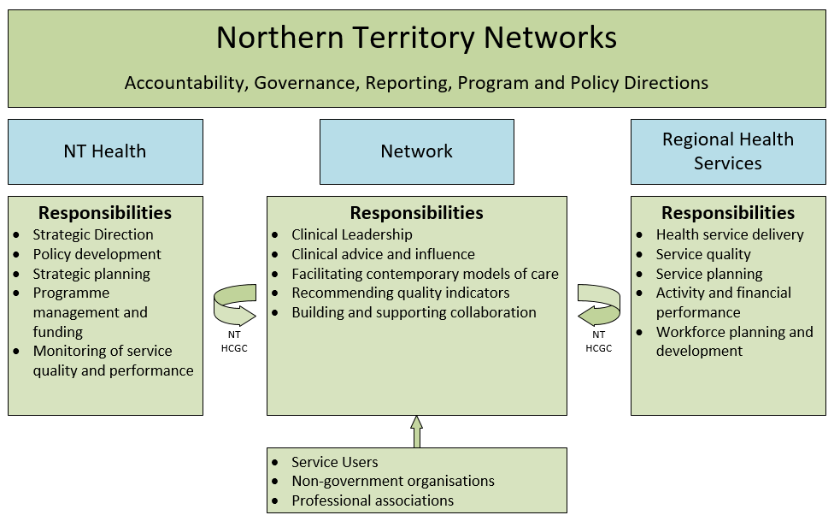

Functions
To enable clinicians, service providers and stakeholder organisations to be actively involved in the delivery and practice of evidence based services. This includes the development guidelines, quality indicators, policies and education requirements to ensure, where appropriate, high quality consistent care.
Key functions:
- To provide a mechanism for collaboration and communication between clinicians, service providers and community stakeholders.
- Promotes an opportunity to exchange information, transfer knowledge, and discuss lessons learnt.
- Communicate alerts, directives and outputs or decisions relating to collaborations with national and international government and non-government agencies.
- To manage a program of service improvement initiatives determined by the Mental Health Collaborative, aligned with available resources and endorsed by the Northern Territory Health Clinical Governance Committee (NT Health CGC).

Principles
Clinical leadership and advice should be guided by the following principles:
- Focus on the improvement in delivery of high quality Mental Health care and to improve the outcomes through a system wide approach.
- Reflects a patient-centred approach to care and service provision that meets individuals’ needs with emphasis on supporting and empowering people to achieve favourable healthcare experiences and outcomes.
- Engage with local health services to improve on current work and avoid duplication.
- Nurture the transformational changes in the health system to improve the clinical engagement with a focus on culture and leadership.
- Promotes a culture of continuous improvement through informed best available evidence.
- The Mental Health Collaborative recognises that the physical, social, spiritual and psychological approach to care requires consideration of a wider perspective.
- The Mental Health Collaborative is respectful in its engagement with Aboriginal communities and respects the voices of Aboriginal individuals and communities.

Preamble
The Clinical Governance, Safety and Quality NT Health Framework sets out the clinical governance, safety and quality requirements for health service providers to ensure effective and consistent clinical care across the Territory. One of the essential components is strategic clinical engagement.
The NT Health Leadership Committee endorsed the Northern Territory Health Clinical Networks Framework in July 2020, to assist in identifying deficiencies in health care provision, and focusing attention on opportunities for sustainable improvements, building consistent and best practice through sector engagement.

Scope and Governance
The Mental Health Collaborative will be the primary mechanism for NT Health to harness clinical leadership and engage clinicians to inform, drive and promote quality improvement, innovation, research and address variation in Mental Health practices within the Northern Territory. Meaningful engagement with clinicians, region healthcare leaders, and key stakeholders will ensure sustained improvement in the safety and quality of mental health care.
This Mental Health Collaborative reports to, and makes recommendations to, the NT Health Clinical Governance Committee, on mental health care as mentioned in the role and functions, and following the principles outlined above.
The Mental Health Collaborative will develop a list of priority works; MHCC Annual Priorities which is endorsed by the NT CGC. The Mental Health Collaborative may develop other structures - e.g.: Working Groups or Communities of Practice – as required to support the work of the Mental Health Collaborative.
Other NT Health committees such as the NT Clinical Senate (NT CS) or other committees as deemed appropriate may forward recommendations to the Mental Health Collaborative for consideration.
Figure 2: NT Mental Health Clinical Collaborative Governance
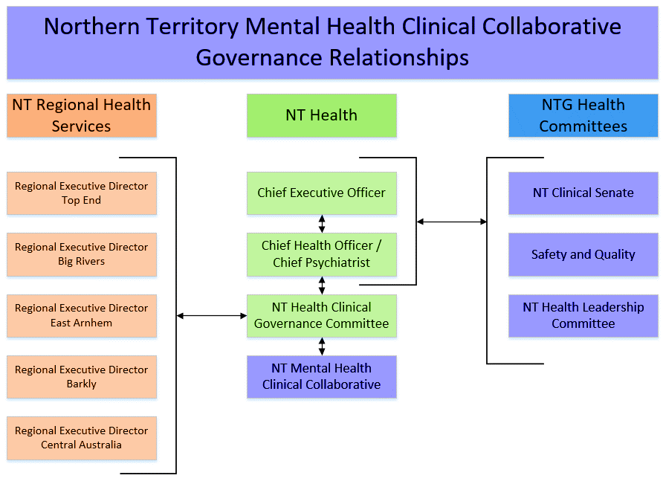

Communication

Communication Plan
The Mental Health Collaborative will ensure an appropriate communication plan is in place to provide effective advice and opinion.

Media Protocols
Mental Health Collaborative members are not endorsed to speak to media on the actions/discussions or priorities of the Mental Health Collaborative.

Membership
Membership is comprised of stakeholders both internal and external to NT Health, Regional Health Services, key stakeholders, and will be: multi-disciplinary; and include those who use and provide services across the continuum of care; include community members; academics/researchers and other representatives which are listed below, which includes, but not limited to.
- Allied Health Practitioner  - Aboriginal Medical Services Alliance Northern Territory (AMSANT)  - Aboriginal health practitioner  - Chief Health Officer  - Chief Psychiatrist | - General Practice  - Non-Government Organisations  - Health Service Management  - Team Health  - Private Hospitals  - Safety and Quality

Recruitment

Co-Chairs
The Co-Chairs of the Mental Health Collaborative are appointed according to their skill and experience in relation to the networks’ purpose and functions. The Co-Chairs will be either one NTG and one NGO persons or one Medical and one non-medical persons.
In the event a Co-Chair is unable to attend, they must provide a proxy who is already a member of the Mental Health Collaborative. If a more suitable or no one is able to proxy is identified the proxy must be agreed by both Chairs before the Mental Health Collaborative meets.
The Chairs will develop the Mental Health Collaborative’ membership which is informed by an expression of interest (EOI) process with potential members supplying a Curriculum Vitae and reasons for applying. EOI’s will be assessed for their expertise and recognition among peers as someone with the ability to contribute to the work of the Mental Health Collaborative.

Leadership and Member Groups
It is expected that subcommittees will be developed out of this Mental Health Collaborative where deemed appropriate. All subcommittees with be required to follow the same expectations of this Mental Health Collaborative.
Other members may be drawn as expert advisors or guest advisors as required.

Expectations of members
All members will:
- Comply with Northern Territory Public Sector Code of Conduct and not divulge confidential information and behave in a respectful and polite manner, exhibiting the highest ethical standards.
- Take a strategic view of issues and not seek to take advantage of their membership to canvass personal or institutional issues.
- Discharge their responsibilities with due care and diligence in accordance with the Terms of Reference.
- Possess the authority and capacity to provide advice and contribute to decisions.
- Consult with appropriate staff where reasonable and necessary to ensure adequate and comprehensive consideration is given to matters.
- Act as Mental Health Collaborative champions with the ability to drive and implement priority projects and initiatives for the Mental Health Collaborative and work professionally through identified enablers and barriers.
All members must:
- Complete a signed Declaration of Interest and Confidentiality Deed Poll.
- If non-NT Health employed, also supply documents of identification, criminal clearance, prior to participation in meetings and receiving meeting papers.
- Nominate items for the agenda via the Secretariat for approval from the Chairs, in accordance with the Mental Health Collaborative Annual Priorities.
- Provide notice of termination of membership to the Chairs in writing.
- If unable to attend, no proxies will be accepted to attend.
- Sign a confidentiality agreement.
Information received during your duties in this Collaborative may be distributed to non-members once written approval of a Collaborate Co-chair has been obtained.

Meetings

Specifications
- Meetings are held once every three months, up to four meetings per year.
- Quorum will be half the membership plus one.
- Nominated proxies will have voting rights and must have the capacity to make decisions on the member’s behalf.

Documentation
Secretariat:
- Support will be provided by NT Health, Office of the Chief Psychiatrist.
- Will be the authorised channel of communication on matters of the NT MHCC via email: ChiefPsychiatrist.Doh@nt.gov.au
- Receives agenda papers and prepares the agenda as directed by the Chairs.
- Distributes papers to members in sufficient time to allow members to consider them before the meeting, a minimum of 5 working days.
- Generates and distributes draft and final minutes of meetings to the members according to the agreed timetable.

Accountability and Performance

Co-Chairs
The Co-Chairs will ensure:
- That meetings proceed on agreed date, and start and finish on time.
- Provide for special out of session meetings or decisions as required.
- Decisions are made on a consensus basis or in any instance where this cannot be achieved, put the issue to a majority vote.
- In the event that a quorum is not achieved, decide whether to continue the meeting.
- That meetings without quorum will have all decisions ratified at the next meeting or out of session.

Work plan development
A work plan takes the strategic goals and priorities identified in the clinical network’s strategic plan and translates these into something practical and achievable. This includes describing the processes by which a team and/or person can accomplish the goals. The work plan provides a useful way of communicating the scope (time resources, inputs, responsibilities and so on) of the project or activity.
Monitoring progress against an agreed work plan is a way of monitoring if the team is on track to achieve its overall goals.
This Mental Health Collaborative will develop an annual work plan which identifies their priorities and activities that will be undertaken for the year. This will form the basis of the reporting required by this group.

Annual Report
An Annual NT Mental Health Clinical Collaborative Report will be provided by a Co-Chair to the Clinical Governance Committee and Chief Executive Officer. The Annual Report will also be made available on line on the NT Health website.

NT Mental Health Clinical Collaborative Annual Priorities
A brief written project summary reporting against the NT MHCC Annual Priorities will be provided to the NT Health CGC every 12 months by the Co-Chairs with a verbal presentation if requested. Members may disseminate project reports to their respective non-government organisations.

NT Mental Health Clinical Collaborative Minutes and ad-hoc reports
Minutes from each meeting will be provided to the NT Health CGC. Ad-hoc reports may be requested by the NT Health CEO, NT Health CHO, NT Health CP or the NT Health CGC.
All other requests for specific reports outside NT Health and not stipulated in Section 7 must be in writing via the NT CHO until the NT CP is appointed.

Chief Psychiatrist Accountabilities
Where it is relevant to their statutory functions, the CP may authorise disclosure to regulatory authority’s summary findings and recommendations from reports.
The CP will also refer any matters arising that relate to professional practice, directly to the manager of the relevant health service organisation for consideration – for example for NT Government (NTG) Health Services this would be the General Managers of each Region.

Evaluation and Review

Terms of Reference
The NT Mental Health Clinical Collaborative will review the Terms of Reference (TOR) after 12 months of operation or following a significant change; and thereafter at least once every two years. The TOR will be forwarded to the NT Health CGC for final endorsement.

Committee Performance
The Chairs will encourage members to feel free to make comments or suggestions for improvements in relation to the Mental Health Collaborative operations at any time.
All members will also be asked to complete a Committee Performance Survey annually as a survey document is comprehensive and cost-effective, and gives all members the chance to make their views known.
Feedback from the Clinical Governance Committee, Chief Executive Officer and/or Health Leadership Committee will be evaluated by the Mental Health Collaborative.

