NT Health Clinical Trials Handbook
  - Clinical Innovation & Research
Document title | NT Health Clinical Trials Handbook
Contact details | NT Health Clinical Innovation & Research Unit
Approved by | Bhavini Patel | Date approved | 17/10/2023
Document review | Annually | TRM number | EDOC2023/98004

Version | Date | Author | Changes made
1.1 | 22 May 2023 | Fransisca Tenorio | Document created and sent for consultation
1.2 | 15 June 2023 | Fransisca Tenorio | Document updated with feedback
1 | 15 July 2023 | Bhavini Patel | Final review and edit

Acronyms | Full form
ACCHO | Aboriginal Community Controlled Health Organisations
A-CTEC | Australian Clinical Trials Education Centre
AE | Adverse Event
AI | Associate Investigator
ATM | Australasian Teletrial Model
ATP | Australian Teletrial Program
CDA | Confidentiality Disclosure Agreement
CRA | Clinical Research Associates
CRC | Clinical Research Coordinator
CRF | Case Report Form
CRO | Contract Research Organisations
CTC | Clinical Trial Coordinator
CTRA | Clinical Trials Research Agreement
GCP | Good Clinical Practice
HREC | Human Research Ethics Committee
IATA | International Air Transport Association
IB | Investigator Brochure
ICAO | International Civil Aviation Organization
IMD | Investigational Medicinal Device
IMP | Investigational Medicinal Product
IP | Investigational Product
ISF | Investigator Site File
MRFF | Medical Research Future Fund
NCTGF | National Clinical Trials Governance Framework
NHMRC | National Health and Medical Research Council
NMA | National Mutual Acceptance
NSQHS | National Safety and Quality Health Service
NT | Northern Territory
PI | Principal Investigator
PICF | Participant Information and Consent Form
PS | Primary Site
RGO | Research Governance Office
SAE | Serious Adverse Event
SIV | Site Initiation Visit
SMF | Study Master File
SOP | Standard Operating Procedure
SS | Satellite Site
SSA | Site Specific Assessment
TGA | Therapeutic Goods Administration

Contents
1. What is a clinical trial? 6
1.1. Why do we need clinical trials? 6
1.2. Who conducts clinical trials? 7
1.3. Who funds clinical trials? 8
1.4. Different phases of clinical trials 8
2. Clinical trials in the NT 10
2.1. NT Health 10
2.2. National Clinical Trials Governance Framework 10
2.3. NT Health Research 11
2.4. NT Health Clinical Trials Register 11
2.5. NT Health Research Peer Support Network 11
2.6. NT Health Clinical Research Committees and Advisory Groups 11
2.7. Consumer engagement in the NT 12
2.8. Australian Teletrial Program – Northern Territory 13
Vision and mission 13
3. How clinical trials work in the NT? 15
3.1. Confidentiality disclosure agreement (CDA) 15
3.2. Feasibility assessment/site selection 15
3.2.1. Contract/budget negotiations 15
3.3. Start-up and regulatory submission 15
3.3.1. Ethics approval - Human Research Ethics Committee (HREC) 16
3.3.1.1. National Mutual Acceptance (NMA) scheme 16
3.3.2. Site specific authorisation – Research Governance Office (RGO) 17
3.3.2.1. Site specific Participant Information and Consent Form (PICF) 17
3.4. Site initiation and activation 18
3.5. Active recruitment 19
3.5.1. Identification of Potential Participants 19
3.5.2. Informed Consent 19
3.5.3. Screening for Eligibility Criteria 20
3.5.4. Enrolment into the Trial 20
3.5.5. Randomisation 20
3.5.6. Investigational product (IP) 21
3.5.7. Specimen collection and management 21
3.6. Ongoing reporting and monitoring 21
3.6.1. Amendment and progress reporting 21
3.6.2. Adverse Events (AE) and Serious Adverse Events (SAEs) reporting 22
3.6.3. Monitoring visits 22
3.7. Closed to recruitment (Follow-up period) 22
3.8. Study Closeout and Archiving 22
4. Education and Training 23
4.1. Good Clinical Practice (GCP) 23
4.2. Australian Clinical Trials Education Centre (A-CTEC) 23
5. References and useful guidelines 25

What is a clinical trial?
The World Health Organisation (WHO) defines a clinical trial as "Any research study that prospectively assigns human participants or groups of humans to one or more health-related interventions to evaluate the effects on health outcomes."
Clinical trials are research studies in which people volunteer to test health-related interventions such as treatments, or tests as a means to prevent, detect, treat or manage various diseases or medical conditions. Some investigations look at how people respond to a new intervention and what side effects might occur. This helps to determine if an intervention works, if it is safe and if it is better than other interventions.
Clinical trials might also test new ways to use or combine existing interventions or observe how people respond to other factors that might affect their health (such as dietary changes).
Clinical trial types include:
- treatment trials to test new treatments, new medicines or combinations of medicines, new therapies such as surgery, the use of new medical devices or new approaches to surgery, biological products, vaccines, behavioural therapies
- diagnostic or screening trials to evaluate tests or procedures to diagnose and detect diseases or conditions
- prevention trials to test new ways to prevent disease including medicines, vaccines, vitamins, or changes to diet, lifestyle or behaviour
Clinical trial activities are carried out across a range of health settings by nurses, doctors, allied health staff and research coordinators at hospitals, outpatient clinics and general practice or university/research institutions. The participants are often patients, although they could also be healthy individuals or people who have been unwell in the past. Clinical trials are subjected to rigid regulations and ethical standards.

Why do we need clinical trials?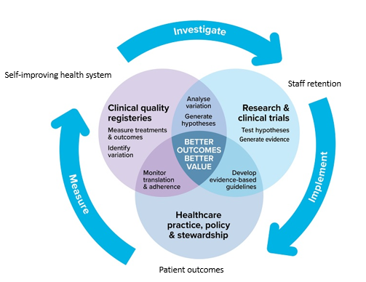
Australian Commission on Safety and Quality in Health Care
Clinical trials are essential to the development of new interventions. For example, without clinical trials, we cannot properly determine whether new medicines developed in the laboratory or by using animal models are effective or safe, or whether a diagnostic test works properly in a clinical setting. This is because computer simulation and animal testing can only tell us so much about how a new treatment might work and they are no substitute for testing in a living human body.
Clinical trials also permit testing and monitoring of the effect of an intervention on a large number of people to ensure that any improvement as a result of the intervention occurs for many people and is not just a random effect for one person.
Most modern medical interventions are a direct result of clinical research. New interventions for most diseases and conditions — including cancer, heart disease, high blood pressure and asthma — have been developed through clinical research. Clinical trials often lead to new interventions becoming available that help people to live longer and to have less pain or disability.
Clinical trials can also help to improve health care services by raising standards of treatment. Australian clinical trials are recognised internationally for including very high quality patient care.

Who conducts clinical trials?
Researchers conducting clinical trials can be part of hospitals and other medical institutions, specialised research groups, universities, or pharmaceutical, medical device and biotechnology companies, or a combination of these.
A clinical trial team often includes doctors and nurses and may also involve other health care professionals, allied health professionals, Aboriginal health workers, biostatisticians and trial coordinators.
Sponsor: The sponsor is an individual, company, institution, or organization responsible for securing the arrangements, initiation, management, and/or financing of a clinical trial. In Australia, all clinical trials must have an Australian entity as the sponsor. The sponsor holds the ultimate responsibility for the quality and integrity of the trial data. They also ensure compliance with regulations, obtain necessary approvals, and uphold ethical principles throughout the trial.
Contract Research Organisations (CROs): companies that provide support and services to pharmaceutical, biotechnology, and medical device industries for conducting clinical trials. CROs are typically hired by the sponsor to assist in various aspects of the trial, such as protocol development, site selection, data management, monitoring, and regulatory compliance
Clinical Research Associates (CRAs): professionals who monitor the conduct of clinical trials at investigational sites. They ensure compliance with protocols, regulations, and GCP guidelines. They visit the trial sites regularly to review study documents, verify data accuracy, assess participant safety, and ensure that the trial is being conducted according to the approved procedures. CRAs act as a liaison between sponsors/CROs and investigators at the study sites.
Investigator: An investigator is an individual involved in conducting a clinical trial at a study site. The investigator ensures that the trial adheres to guidelines such as ICH Good Clinical Practice (GCP) E6 (R2). There can be different types of investigators, including Coordinating Principal Investigators, Principal Investigators, and Associate Investigators. Investigators contribute to the overall management and oversight of the trial at their respective study sites.
Clinical Research Coordinator (CRC) / Clinical Trial Coordinator (CTC): A research professional who works at a clinical research/trial site under the direct supervision of a Principal Investigator, whose activities are conducted in accordance with GCP guidelines, the National Statement, and the National Clinical Trials Governance Framework. Other terms may include “Clinical Study Coordinator” or “Trial Coordinator” or “Research Coordinator” or “Research Nurse”.

Clinical Trial Team: consists of individuals, identified by the Investigator, who are responsible for trial coordination, data collection and data management. This team may include roles such as clinical research coordinators, research nurses / midwives, Aboriginal Health Practitioners, principal/associate Investigators and clinical trial pharmacists. Their respective roles, will be defined in the Delegation Log for the research study and usually, encompasses the following:
- Participant recruitment and enrolment
- Obtaining consent from prospective participants, meeting with research participants, and collecting and recording information from them
- Ensuring consistent study implementation according to the protocol
- Managing data and ensuring its integrity
- Dispensing and administering the investigational product or test, if applicable
- Ensuring compliance with regulatory and reporting requirements

Who funds clinical trials?
Clinical trials are sponsored or funded by various organisations or individuals including government departments and agencies, research groups, foundations, charities, and pharmaceutical, medical device and biotechnology companies.
- A commercially sponsored clinical trial is where a commercial entity such as a pharmaceutical company or medical device company develops the product being tested, develops the protocol, funds the conduct of the trial and provides indemnity to participating sites.
- A collaborative group trial is where a group of clinicians jointly develop a trial protocol. They may apply for funding through various research grants or from commercial sponsors to run the trial, or rely on in-kind support from each participating institution. In this situation, the collaborative group is the sponsor of the trial, however, they may negotiate for one or more institutions to undertake Sponsor responsibilities on behalf of the collaborative group.
- Investigator-initiated trials are clinical trials that are initiated, designed, and conducted by independent researchers or investigators. They together, with their institution accepts the risk and responsibility for the trial and undertaking sponsor-related duties. These trials are often unfunded and undertaken within existing resources but may receive financial support through grants (ie. National Health and Medical Research Council (NHMRC)) or other funding mechanisms.

Different phases of clinical trials
Many clinical trials to develop new interventions are conducted in phases. In the early phases, the new intervention is tested in a small number of participants to assess safety and effectiveness. If the intervention is promising, it may move to later phases of testing where the number of participants is increased to collect more information on effectiveness and possible side effects.
- Phase I Clinical Trial – Is the Intervention safe?
Test a new biomedical intervention for the first time in a small group of people (e.g. 20-80) to evaluate safety (e.g. to determine a safe dosage range and identify side effects).
- Phase II Clinical Trial – Does the intervention work?
Study an intervention in a larger group of people (several hundred) to determine efficacy (that is, whether it works as intended) and to further evaluate its safety.
- Phase III Clinical Trial – is the intervention better than what is already available?
Study the efficacy of an intervention in large groups of trial participants (from several hundred to several thousand) by comparing the intervention to other standard or experimental interventions (or to non-interventional standard care). Phase III studies are also used to monitor adverse effects and to collect information that will allow the intervention to be used safely.
- Phase IV Clinical Trial – What else do we need to know?
Undertaken after an intervention has been marketed. These studies are designed to monitor the effectiveness of the approved intervention in the general population and to collect information about any adverse effects associated with widespread use over longer periods of time. They may also be used to investigate the potential use of the intervention in a different condition, or in combination with other therapies.
- Other clinical trials
Researchers may also conduct exploratory studies, sometimes referred to as ‘Phase 0 trials’ or ‘pilot studies’ or ‘first in human’. These come before Phase I trials and are used to test how the body responds to an experimental drug. In these studies, small doses of the new drug are given once or for a short time to a very limited number of people.

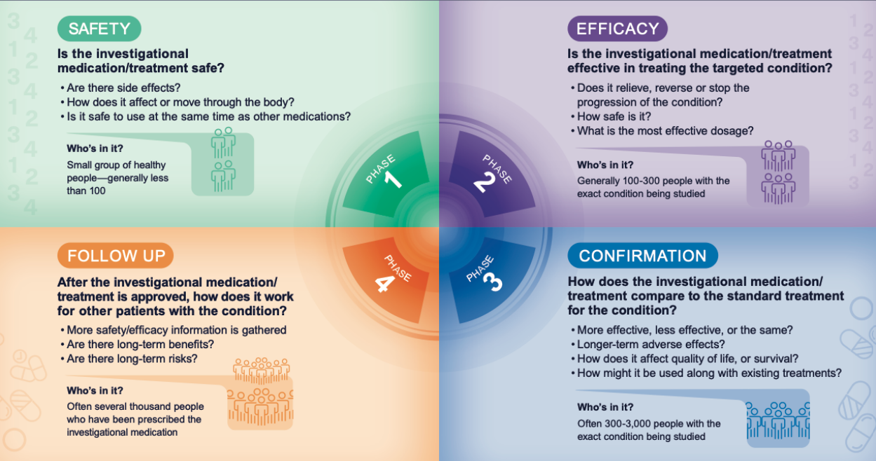
https://www.abbvieclinicaltrials.com/resources/clinical-trial-phases/

Clinical trials in the NT

NT Health
NT Health extends across 5 regions, 6 hospitals and 74 health clinics that make up the Regional Health Services:
- Top End
- Big Rivers
- East Arnhem
- Central Australia
- Barkly.
Visit Org structure (nt.gov.au) to view NT organisational structure.
Visit NT Health regional health service page to find out more about NT Health services including Aboriginal Community Controlled Health Organisations (ACCHO) services across the five regions.
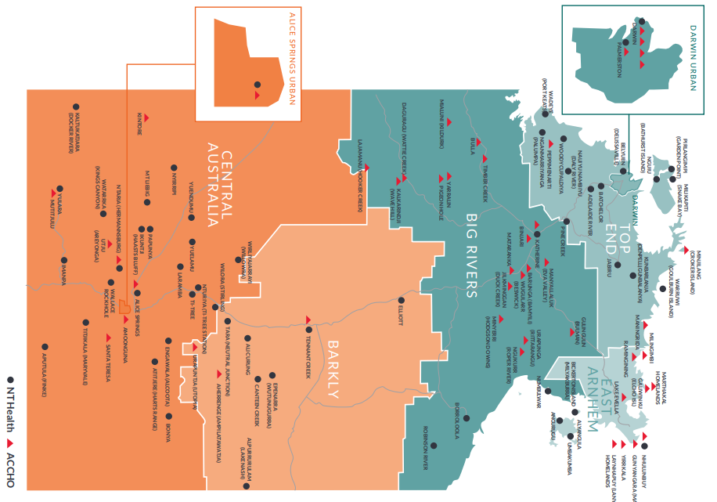

National Clinical Trials Governance Framework
The safety and quality of clinical trials and research is embedded through implementation of the National Clinical Trials Governance Framework.
Developed by the Australian Commission on Safety and Quality in Health Care, it aligns with the National Safety and Quality Health Service (NSQHS) Standards towards Standard 1 Clinical Governance and Standard 2 Partnering with Consumers.
Adhering to the governance framework entails establishing and implementing appropriate governance structures and processes to protect the rights, safety, and well-being of trial participants. This involves maintaining ethical conduct throughout the trial, implementing effective oversight mechanisms, monitoring participant safety, and promptly reporting any adverse events.
For further information, please contact the chair of the relevant Clinical Innovation and Research Committee/Advisory group (see section 2.6), Safety and Quality Officer or the NT Health RGO.

NT Health Research
Promoting research is central to the achievement of NT Health’s goals and strategic objectives (nt-health-strategic-plan-2023-2028.pdf) to achieve “Great Health for Territorians”.
Research plays a crucial role in ensuring health care is effective and evidence based, discovering new treatments, developing effective models of care, providing alternative options for patients, boosting recruitment and retention of health staff and contributes to NT Health being a learning organisation.
NT Health conducts research in a range of capacities and in partnership with a range of organisations to:
- Develop a priority research agenda aimed at improving health and health care for all Territorians
- Grow research capacity and capability, including the establishment of NT wide governance and support structures
- Strategic sourcing of funding for research that optimises health outcomes for Territorians
- Ensure curriculum and workforce development provides quality teaching and learning
- Implement, test and embed research-based solutions to Territorian health care challenges in our health system.

NT Health Clinical Trials Register
NT Health is actively conducting and participating in clinical trials to ensure Territorians have access to novel treatments, tests and models of care. Visit NT Health clinical trials register | NT Health to find out on all active clinical trials across NT Health.

NT Health Research Peer Support Network
The NT Health research peer support network is a monthly gathering specifically designed for clinical research coordinators. NT Health research peer support network provides a valuable opportunity for clinical research coordinators to foster a sense of community, share resources and knowledge, and support one another in their professional growth.
If you want to be involved, please email ATP-NT@nt.gov.au for more information and to be added to the distribution list.

NT Health Clinical Research Committees and Advisory Groups
Each region has established clinical innovation and research committees and advisory groups to provide leadership, governance, assurance and oversight of the effectiveness of research activities through the following activities:
- reviewing proposals for clinical research to be undertaken in terms of feasibility and relevance to the challenges and opportunities
- ensuring the conduct of clinical trials and clinical research meet the NCTGF standards
- routinely review and provide reports on clinical research and clinical trial performance measures to the senior leadership team
- monitor and report any variation in clinical research and clinical trial service provision, complaints, compliments including human resource matters using the NT Health incident monitoring system
- Monitor and report on clinical trial performance measures including:
  - Number of new trials; phase and sponsor type
  - Performance of current trials including any risk mitigation actions required
  - Tracking recruitment numbers for each clinical trial
  - Total inbound (internal and external) investment annually
  - Quality improvement activities
  - Safety and risk management

Consumer engagement in the NT
Consumer engagement is a fundamental aspect of conducting clinical trials in the NT. By actively involving consumers in the research process, NT clinical trial staff can tap into valuable insights and perspectives that enhance trial design, recruitment and overall trial outcomes. Effective consumer engagement fosters collaboration, trust and transparency between researchers, healthcare professionals and patients, ensuring that the trials are aligned with the needs and preferences of the community.
Useful links on consumer engagement can be found below:
- Stakeholder and Consumer Engagement: http://internal.health.nt.gov.au/governance/stakeholder
- Standard 2 Partnering with Consumers: http://internal.health.nt.gov.au/governance/terhs-communityengagement/standard2/Pages/default.aspx
- Partnering with Consumers e-learning modules: http://internal.health.nt.gov.au/governance/terhs-communityengagement/framework/Pages/default.aspx
- Health Advisory Committee (​​HAC)
- Regional Commu​nity Engagement Groups (RCEGs)​

Patient information: Understanding Research and Clinical Trials can be found here:
https://health.nt.gov.au/__data/assets/pdf_file/0009/1288296/patient-information-understanding-research-and-clinical-trials.pdf

Australian Teletrial Program – Northern Territory
NT Health is a national partner of the Australian Teletrial Program (ATP), funded by the Commonwealth Government’s Medical Research Future Fund (MRFF) – national critical infrastructure initiative – 2019 rural, regional and remote clinical trial enabling infrastructure grant.
The initiative aims to improve access to and participation in clinical trials for rural, regional and remote Australians. The program will implement a scaled-up version of the Australasian Teletrial Model (ATM) to facilitate and expand clinical trial activity across all of Australia, enabling residents to access trials closer to home.

Vision and mission
ATP-NT VISION - To improve health outcomes for Territorians, especially those living in rural, regional and remote regions, through access to quality clinical trials
ATP-NT MISSION - Building NT Health’s capacity and capability to undertake quality clinical trials by providing trained workforce, resourced sites, adequate infrastructure and an interconnected system locally and nationally.
A teletrial is a group of clinical trial sites that work together to conduct a clinical trial under the supervision of a primary site.
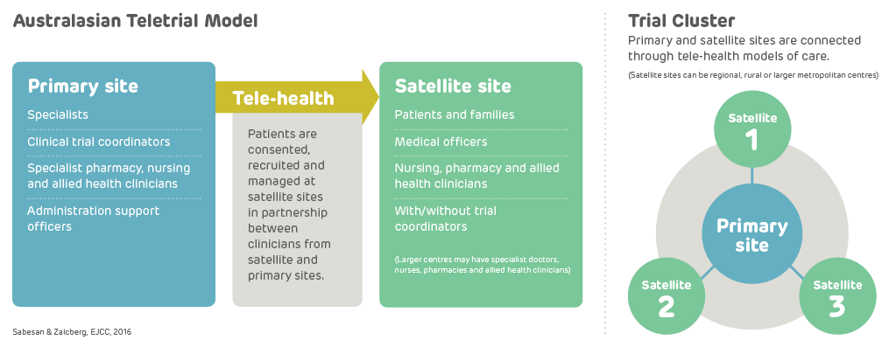
A teletrial uses tele-technology to communicate between the primary site and satellite site/s and enable delivery of aspects of a clinical trial closer to home for patients particularly in regional, rural and remote locations. A Principle investigator (PI) supervises an Associate Investigator (AI) to conduct a clinical trial at a satellite site which is geographically remote from the PI’s primary site.
The PI remains responsible for the trial. A detailed supervision plan is required, in addition to a delegation log required as part of GCP for all satellite sites regardless of experience. Trial participants may have trial visits at both the primary and satellite sites, as determined by the protocol and supervision plan.
The conduct of the trial is detailed under the ‘head agreement’ between the sponsor and the PI’s institution and a sub-contract between the primary site and the satellite site institutions.
The ATP-NT team will work with primary and satellite sites (a teletrial cluster) to start-up the trials on behalf of the cluster and will guide and assist sites in the completion of required regulatory processes for site authorisations through the local RGO. They will also conduct a site evaluation, provide education, trials related equipment and resources to build clinical trial capacity and capability at satellite sites and all clinical trials sites generally.
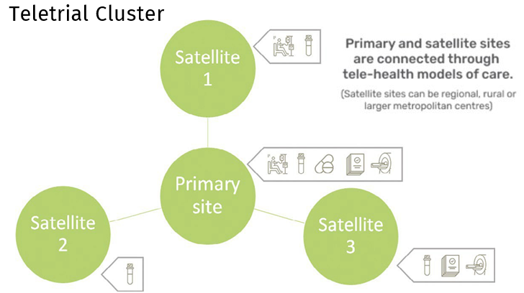

Contact:
Australian Teletrial Program – Northern Territory
Block 4, Level 1, Yellow Wing, Royal Darwin Hospital, Tiwi NT 0810
PO Box 41326, Casuarina, NT 0811
Phone: (08) 8922 8708
Email: ATP-NT@nt.gov.au
Website: Australian Teletrial Program – Northern Territory | NT Health

How clinical trials work in the NT?

Confidentiality disclosure agreement (CDA)
Trial sponsors, especially industry or pharmaceutical companies, usually require the signing of a confidentiality disclosure agreement (CDA) before sharing the trial protocol. Please send any CDA to the RGO for review and further progress towards signing. The review process is anticipated to be completed within 1-3 business days.

Feasibility assessment/site selection
Conducting clinical trial feasibility is one of the first steps in clinical trial conduct. Clinical trial feasibility is a process of evaluating the possibility of conducting a particular clinical program/trial in a particular geographical region with the overall objective of optimum project completion in terms of timelines, targets and cost.
A feasibility assessment determines the practicality of a proposed clinical trial/project at a site. Feasibilities can help you determine whether a new clinical trial is relevant to your patient population, has scientific/clinical merit, is viable to conduct at your site and if it can be recruited to.
A clinical trial site should have the appropriate facilities and resources available to conduct a trial, making the site an attractive proposition to sponsors. When assessing your site’s capability and capacity to take on a particular trial, consider site facilities, staff capacity, PI availability, recruitment targets and methodology, and other competing trials/sites. Sponsor may wish to conduct a Site Selection Visit to assess site feasibility.

Contract/budget negotiations
It is essential to involve the NT Health Research Governance Office (RGO) at an early stage when considering to be a clinical trial site. The RGO will review the clinical trial research agreement and provide assistance with budget negotiations.
Clinical trial research agreement (CTRA) is a legally binding document that governs the relationship between the sponsor (the entity providing the study drug, device, financial support, or proprietary information) and the institution (the clinical trial site). It covers important aspects such as confidentiality, intellectual property, ownership of data, insurance, and indemnity. The Medicines Australia CTRA is a widely used standard form for clinical trial research agreements.
The unit's business/performance managers must be engaged also crucial during the negotiation process. These managers have expertise in financial matters and can provide valuable insights and support in navigating budget discussions associated with the clinical trial. They can help assess the costs involved, negotiate fair compensation and ensure financial sustainability for the institution. To further facilitate budget negotiations, the NT Health Clinical Trials Fee Schedule has been developed - Fee schedules | NT Health.

Start-up and regulatory submission
Prior to commencing a clinical trial, researchers require both ethics and governance approval (commonly referred to as site specific authorisation). A Human Research Ethics Committee (HREC) provides ethics approval, whilst an institution provides Site Specific Authorisation for a study to be conducted at a particular site. Although an ethics committee may ethically approve a project, Site Specific Authorisation is required to ensure that a specific site has the personnel and resources to be able to conduct the research.

Ethics approval - Human Research Ethics Committee (HREC)
The Human Research Ethics Committee of NT Health and Menzies School of Health Research (NT HREC) operates in accordance with the National Health and Medical Research Council’s (NHMRC) National Statement on Ethical Conduct in Human Research. The HREC is registered with the NHMRC and certified for multi-site review.
The NT HREC supports the research activities of the NT Department of Health and Menzies School of Health Research. It also considers ethics applications submitted by non-government service providers and other research institutions from outside the NT who wish to conduct research across the NT.
Researchers in the NT should be aware that the NT HREC Part D is mandatory when conducting research involving Aboriginal participants. This requirement ensures that researchers address and manage areas such as reciprocity, respect, equity, responsibility, cultural continuity, spirit, and integrity for Aboriginal participants.
The NT HREC has established an Aboriginal sub-committee specifically tasked with reviewing applications and providing recommendations for research involving Aboriginal participants, if necessary.
If the research study intends to recruit Aboriginal individuals, it is beneficial to consider including an Aboriginal researcher in the study. The NT HREC may request the involvement of an Aboriginal researcher to enhance the study's outcomes.
Additionally, if an NT researcher focuses on a specific Aboriginal community or location, obtaining endorsement from an Aboriginal Elder for research within that specific community may be required by the NT HREC.
The NHMRC provides valuable resources on this topic, including guidelines on ethical research practices and ensuring the integrity and compliance of research projects.
- Ethical conduct in research with Aboriginal and Torres Strait Islander Peoples and communities | NHMRC: https://www.nhmrc.gov.au/about-us/resources/ethical-conduct-research-aboriginal-and-torres-strait-islander-peoples-and-communities
- Keeping research on track II | NHMRC: https://www.nhmrc.gov.au/about-us/resources/keeping-research-track-ii
These resources serve as valuable references for researchers seeking to conduct research/clinical trials with Aboriginal and Torres Strait Islander Peoples and communities in a manner that aligns with ethical principles and responsibilities
Contact:
Ethics administration officer
Phone: (08) 8946 8687
Location: Menzies School of Health Research, John Mathews Building (JMB), Building 58, Royal Darwin Hospital Campus, Darwin, NT
Emai: NTHREC@menzies.edu.au
Website: Ethics - Menzies

National Mutual Acceptance (NMA) scheme
The Northern Territory has agreed to be part of the National Mutual Acceptance (NMA) Scheme for single ethical review. For clinical trials intending to enrol participants from the Northern Territory under the NMA scheme, the Chair of the HREC and the ethics administrator undertake a risk-based assessment of the application and determine if further review in the NT is warranted. For further information on NMA application process, visit NT HREC website 3. National Mutual Acceptance (NMA) application process - Menzies.

Site specific authorisation – Research Governance Office (RGO)
All research conducted with NT Health staff, clients/patients, sites and/or data must be approved through the correct governance processes which broadly address the quality, safety, privacy and confidentiality, risk management, financial management and ethical acceptability of research.
Processes and guidelines have been developed to support the changes to institutional governance procedures for conducting research within NT Health, bringing the NT in line with the National Clinical Trials Governance Framework and national best practice in research governance. The role of the NT Health Research Governance Office is to ensure research is conducted according to established ethical principles, guidelines for the responsible research conduct, relevant legislation, regulations and NT Health policies.
The governance review undertaken will depend on the type and risk of research. Assessment of applications occurs through Site Specific Assessment (SSA), clearance for clinical audits, quality assurance and case studies, and/or access request for research review; assessing the resources at the NT Health site and whether they’re sufficient to ensure the satisfactory conduct and completion of the project. As part of the governance review process for clinical trial site selection, endorsements from relevant delegates are required. Researchers are advised to contact the RGO for guidance on identifying the appropriate delegates to approve their application.
Application to the NT Health RGO will need to be submitted via online submission platform - Research Governance NT (ReGNT) Submissions for new research | NT Health

Site specific Participant Information and Consent Form (PICF)
The PICF is a written document approved by an ethics committee, providing information to potential participants and recording their decision to participate in the trial.
NT HREC templates for PICF can be found here 8. Guidelines, checklists, resources and links - Menzies
NT Health RGO usually requests for site specific PICF to include NT Health name block, site PI details and RGO details as per below:
The conduct of this study at [name of site] has been authorised by Northern Territory Health. Any person with concerns or feedback (complaints or compliments) about the conduct of this study may contact the NT Health Research Governance Officer on 08 8922 7764 or email nthealth.rgo@nt.gov.au and quote reference number [insert SSA reference number].
Contact:
NT Health Research Governance Office (NT Health RGO)
Block 4, Level 1, Yellow Wing, Royal Darwin Hospital, Tiwi NT 0810
PO Box 41326, Casuarina, NT 0811
Phone: (08) 8922 7561
Email: nthealth.rgo@nt.gov.au
Website: Research Governance | NT Health

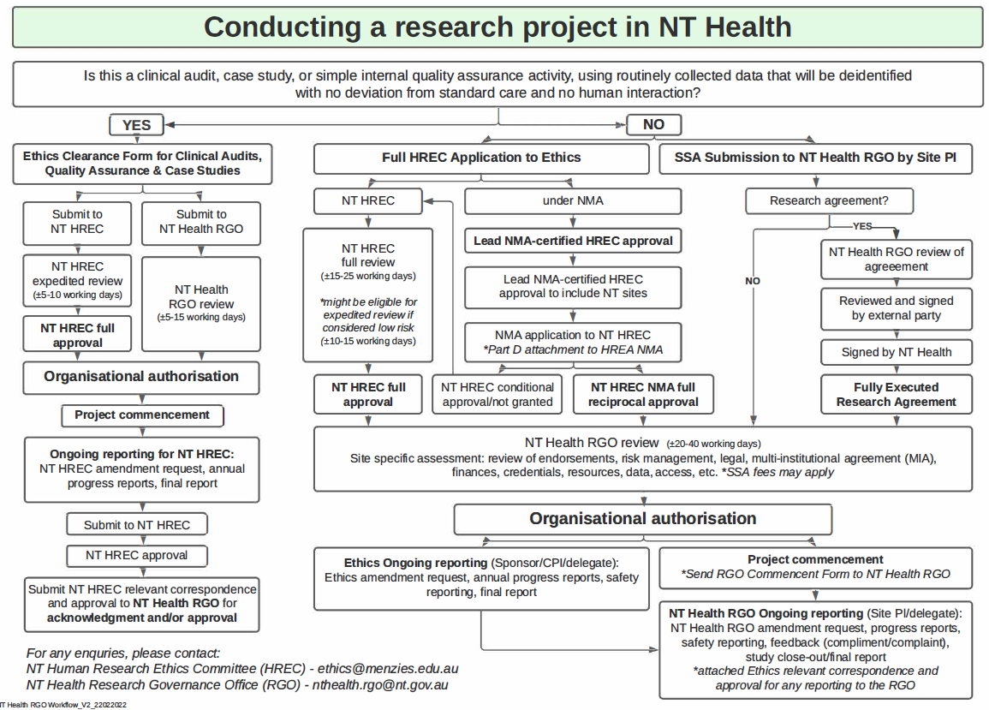

Site initiation and activation
Site initiation and activation are crucial steps in the process of conducting a clinical trial. During site initiation, a site visit is conducted to ensure that the site has all the necessary documents, approvals, and agreements in place to conduct the trial in compliance with the approved protocol and regulatory guidelines. The following elements are typically assessed during a site initiation visit (SIV):
- The site has all essential documents (ie ethics approval, site organisational authorisation, all approved documents, delegation log, training log, IMP handling SOP, lab manual/accreditation, and other relevant documents as requested by trial sponsor) in place for the site to conduct the clinical trial in compliance with the approved protocol and applicable regulatory guidelines.
- The site is aware of all the sponsor’s procedures and SOPs for study conduct (such as safety recording and reporting, amendments, notification of any urgent safety measures/ non-compliance or serious breaches) and has read and understood each.
- The site is met with all the required regulatory and sponsor requirements.
In addition to the above, certain documents and logs are established during site initiation:
- Study Master File (SMF) or Investigator Site File (ISF): This is a folder or electronic system that contains all the essential documentation and source documents related to the study. It should be established at the investigator/institution's site and the sponsor's office. The SMF should have an index of contents and indicate the location of all essential/source documents. The storage system used should enable proper document identification, version history, search, and retrieval.
- Case Report Form (CRF): The CRF is a document, either in printed or electronic format, designed to record all the protocol-required information for each trial participant. The data collected in the CRF serves as the basis for the trial report, publications, and regulatory approval.
- Delegation Log: The delegation log lists the qualified and trained individuals to whom the principal investigator has delegated significant study-related duties and functions. It assigns study-specific roles and responsibilities to each staff member on the study team and should be actively maintained (not constructed retrospectively) so there is evidence of appropriate delegation before any trial activities are undertaken. Each entry is signed and dated by the delegates and countersigned by the Principal Investigator.
- Training Log: The training log records all training undertaken by trial staff members who have been delegated clinical trial-related duties. It documents the date, training content, trainer's signature, trainee's signature, and is kept up to date throughout the trial.
Once the site initiation process is complete and all necessary requirements are met, site activation confirms that the site is ready to start the trial. It marks the beginning of trial recruitment and the enrolment of participants at the site.

Active recruitment
The patient enrolment process for clinical trials involves identifying potential participants, obtaining informed consent, screening for eligibility criteria, and enrolling eligible individuals into the trial.

Identification of Potential Participants
The trial team, in collaboration with healthcare professionals, will identify potential participants based on the trial's inclusion and exclusion criteria. Potential participants may be identified through various means, such as referrals from healthcare providers, medical records review, advertising, or other recruitment strategies approved through governance process.

Informed Consent
The trial team will obtain informed consent from each potential participant before any trial-related procedures occur. Informed consent will be obtained according to established ethical guidelines and regulatory requirements. Participants will be provided with sufficient information about the trial purpose, procedures, potential risks and benefits, confidentiality and their rights as a clinical trial participant. Informed consent documentation, including consent forms, will be completed and filed appropriately. The trial team will ensure that potential participants have ample opportunity to ask questions and fully understand the information provided.
In clinical trials involving NT populations, such as Aboriginal and culturally and linguistically diverse individuals, the trial team must conduct a culturally sensitive and accessible informed consent process. This may involve:
- providing interpreter services to facilitate effective communication for individuals with language barriers
- engaging Aboriginal Liaison Officers to bridge cultural gaps and provide cultural support during the informed consent process
- utilising visual aids and using plain language to enhance understanding for participants from diverse linguistic and cultural backgrounds
- ensuring potential participants have sufficient time to ask questions, seek clarification, and discuss any concerns related to the clinical trial to promote informed decision-making.

Screening for Eligibility Criteria
In the screening process for a clinical trial, potential participants will be thoroughly evaluated to determine their eligibility based on predefined inclusion and exclusion criteria. This process ensures that the trial participants meet the specific requirements outlined in the trial protocol. Potential participants will undergo a comprehensive screening process which may involve medical history review, physical examinations, laboratory tests, imaging studies, or other assessments as specified in the trial protocol.
Inclusion criteria are specific characteristics or conditions that participants must have to be eligible for the trial. Exclusion criteria are factors that would disqualify individuals from participating in the trial. These criteria are determined based on the research objectives and safety considerations. Eligibility confirmation is conducted by qualified healthcare professionals, such as doctors or nurses, who have the necessary expertise to assess the potential participants.
The screening for eligibility criteria is a critical step in the clinical trial process as it helps ensure that the enrolled participants meet the specific criteria necessary for the trial's objectives and contribute to the scientific validity and reliability of the study results.

Enrolment into the Trial
Eligible participants will be enrolled in the clinical trial, following completion of the informed consent process and confirmation of their eligibility. The trial team will document the enrolment process, including participant identification, enrolment date and any necessary trial-specific procedures or requirements as specified in the trial protocol.
Source data and Source documents play a crucial role in the clinical trial process:
- Source Data: refers to all original records and certified copies of original records that contain clinical findings, observations, or other activities necessary for the evaluation and reconstruction of the trial. Accurate collection of Source Data is essential for compliance with Good Clinical Practice (GCP) guidelines. Source Data should be attributable, legible, contemporaneous, original, accurate, and complete.
- Source Documents: the original documents, data, and records where the Source Data was first recorded. These can include medical/hospital records, clinical and office charts, laboratory notes, diaries, pharmacy dispensing records, and more. Source Documents substantiate the existence of the participant and the integrity of the trial data collected.
Both source data and source documents are crucial for maintaining the accuracy and reliability of trial data. They serve as evidence of the participant's involvement in the trial and provide a comprehensive record of their medical history and trial-related activities.
By ensuring accurate documentation and adherence to GCP guidelines, the enrolment process establishes a solid foundation for the conduct of the clinical trial and contributes to the integrity and validity of the trial results.

Randomisation
Randomisation is a crucial component of clinical trials. It involves assigning participants to different treatment groups by chance, according to the trial protocol and established randomization procedures. The purpose is to ensure unbiased comparison between treatment groups and determine the effectiveness and safety of new interventions compared to standard treatments. The experimental group(s) receive the new treatment(s) being tested, while the control group receives the current standard treatment, which can be the best existing treatment, no treatment, or a placebo.

Investigational product (IP)
The clinical trial team is responsible for the onsite investigational product (IP).Key definitions related to the IP:
- Investigational Product (IP): Any product or intervention being investigated, tested, or used as a placebo or reference point in a clinical trial. This includes pharmaceutical forms of active ingredients or placebos used in a trial, including products with marketing authorisation used in different ways or for unapproved indications to gain further information. The Sponsor or their delegate, is responsible for the provision and maintenance of the IP.
- Investigational Medicinal Device (IMD): A medical device that is being assessed for safety or performance in a clinical investigation. It can include medical devices already on the market that are being evaluated for new intended uses, new populations, new materials, or design changes.
- Investigational Medicinal Product (IMP): A pharmaceutical form of an active ingredient or placebo used as a reference or being tested in a clinical trial. This can include products with marketing authorisation used in ways different from the approved form, for unapproved indications, or for gaining further information about an approved use.
- Investigational Brochure (IB): A compilation of clinical and non-clinical data on the experimental products intended for use in the clinical trial. It provides trial organisers and staff with an understanding of the trial's rationale, informing compliance with the protocol requirements. The information in the IB enables a risk/benefit assessment essential for considerations by the Human Research Ethics Committee (HREC).
- Therapeutic Goods Administration (TGA): the Australian Government Department of Health agency responsible for the regulation of, supply, import, export, manufacturing and advertising of therapeutic goods in Australia.
The clinical trial team's responsibilities related to the IP include proper storage, handling, and administration, monitoring inventory levels, coordinating the distribution and return of the IP, documenting any deviations or discrepancies, collaborating with the sponsor regarding the IP, ensuring participant compliance with the trial protocol, adhering to regulatory requirements and guidelines, monitoring the safety and efficacy, maintaining accurate records of usage, and assisting with regulatory submissions.

Specimen collection and management
The clinical trial team is responsible for managing specimen collection and ensuring adherence to protocols and guidelines. The team must follow approved protocol and laboratory manual for specimen collection to maintain consistency and accuracy. This includes labelling each specimen with as participant identification, collection date and time, and type of specimen. The team must ensure that the specimens are stored appropriately and safely transported from the collection site to the designated laboratory or storage facility to maintain their integrity and stability.
If the biological samples are being shipped by air requirements outlined with the International Air transport Association (IATA) and International Civil Aviation Organization (ICAO) are mandatory. This includes documentation that all clinical trials staff and/or delegates who are involved in packaging and shipping of infectious waste/dangerous goods are appropriately qualified and trained.

Ongoing reporting and monitoring

Amendment and progress reporting
Any amendments made to the trial protocol, such as changes to the study design, participant eligibility criteria or study procedures, will need to be documented promptly. These amendments will need to be reported to the HREC and RGO (as applicable) for review and approval before implementation to ensure that any modifications maintain the ethical standards and regulatory requirements of the trial.
Additionally, the trial team is also responsible for providing regular progress reports to HREC and RGO in accordance with regulatory guidelines and institutional requirements. These progress reports, typically submitted annually, update the authorities on the trial's status, outcomes, and any significant developments. The NT Health requirement can be found on NT Health Research website

Adverse Events (AE) and Serious Adverse Events (SAEs) reporting
The trials team is responsible for ongoing safety monitoring of participants throughout the trial. This involves regular assessments and evaluations to identify and document any adverse events or changes in participants' health status. In Australia, The National Health and Medical Research Council (NHMRC) Safety monitoring and reporting in clinical trials involving therapeutic goods guidelines provide a framework for ensuring participant safety and minimising risks during the trial.
Adverse events (AE) are defined as any unfavourable or unintended medical occurrences that happen to participants during the trial, regardless of their relationship to the investigational product or intervention.
Serious adverse events (SAE) are events that result in death, life-threatening situations, hospitalization or prolonged existing hospitalization, disability or other significant medical events. Immediate attention and prompt reporting to the relevant authorities are required for SAEs.
Accurate and detailed documentation of adverse events is crucial. The trials team must collect relevant data, including the nature and severity of the event, timing, duration, any interventions or treatments provided and the outcome. This information is essential for comprehensive safety assessment and analysis. The guidelines also specify reporting timelines for adverse events, including the timeframe for reporting serious adverse events. These timelines ensure that HREC, regulatory authorities (TGA), sponsors and RGO are informed in a timely manner to ensure appropriate safety oversight. All adverse events need to be documented in the NT health incident management system and reported to the NT Health RGO

Monitoring visits
Monitoring visits are conducted by Clinical Research Associates (CRAs) to assess the progress of clinical trials and ensure compliance with protocols, regulations, and GCP guidelines. CRAs verify data accuracy, check adherence to the protocol, confirm proper handling of investigational products, review informed consent procedures, monitor adverse events reporting, and ensure regulatory compliance. These visits help maintain data integrity, participant safety, and overall trial quality.

Closed to recruitment (Follow-up period)
During the follow-up period of a clinical trial, participant enrolment is typically closed, and the emphasis shifts towards monitoring and evaluating the enrolled participants. This phase involves closely following the trial protocol and conducting scheduled visits, assessments, tests, or interventions as specified in the trial design.

Study Closeout and Archiving
During the study closeout process, the clinical trials team has several important responsibilities:
- Data Verification and Cleaning: They ensure the completeness, accuracy and proper documentation of collected data. They review the data for missing information, inconsistencies and errors. They work with the data management team to resolve any issues.
- Documentation and Archiving: The clinical trials team organises and maintains all study-related documents, ensuring they are properly labelled, indexed, and stored according to regulatory and institutional guidelines. They securely archive the study records for future reference and regulatory compliance.
- Regulatory Compliance: They ensure all regulatory requirements and reporting obligations are met, submitting final reports and documentation to regulatory bodies and ethics committees as required.
- Study Closeout Activities: The team assists in coordinating the logistics of study closeout, including scheduling and conducting closeout meetings, facilitating the collection and proper disposal or return of equipment and materials used in the trial.
- Final Study Report Preparation: They collaborate with the principal investigator and team members to compile the study findings, statistical analyses and supporting documentation. They contribute to writing sections of the final report, ensure accuracy and consistency, and assist with formatting and finalising the report before submission

Education and Training

Good Clinical Practice (GCP)
The GCP guideline is an internationally recognised standard for upholding ethical principles and ensuring scientific quality in clinical trials. In line with the National Clinical Trials Governance Framework, it is mandatory for clinical trial investigators and their teams to possess the necessary knowledge of GCP principles through appropriate training.
To comply with this requirement:
- All members participating in clinical trial teams, including PI, AI and research staff must hold a valid and up-to-date GCP training certificate prior to commencing any activities related to a clinical trial.
- The GCP training course undertaken must meet the minimum criteria established by TransCelerate Biopharma Inc. and be listed on their official website.
- It is recommended that individuals refresh their GCP training every three years to stay updated with the latest guidelines and best practices.

Australian Clinical Trials Education Centre (A-CTEC)
NT Health Clinical Innovation and Research, supported by the Australian Teletrial Program, is providing FREE access to training for everyone who conducts clinical trials or would like to develop their skills in this area across Northern Territory regarding of which organisation they work for.
A-CTEC is a not-for-profit, member based education platform, hosting a suite of evidence-based, interactive clinical trials education opportunities suitable for a range of learning needs.
A-CTEC enables capacity and capability building of the clinical trials workforce through easy access to world-class education and training opportunities. It provides a collaborative forum to share resources, knowledge and expertise and allows reporting for accreditation purposes. It provides:
- Education and training that caters to the various levels of experience and competency of the clinical trials workforce
- Courses which are interactive, practical, multi-modal and evidence-based
- TransCelerate Good Clinical Practice Training
- Role specific competency frameworks
- Networking opportunities for the clinical trials workforce
- Reporting for accreditation
The training available through A-CTEC will be valuable for: study investigators, study coordinators, research nurses, clinical trial assistants, clinical trial pharmacists, HREC, RGO and all staff involved in clinical trials regardless of their role or location.
For further information, sign up to Australian Clinical Trials Education Centre (myopenlms.net)

References and useful guidelines
- NT Health Research page: https://health.nt.gov.au/data-and-research/nt-health-research/nt-health-overview
- NT HREC page: https://www.menzies.edu.au/page/Research/Ethics_approval/
- Australian Teletrial Program (ATP) national website: https://australianteletrialprogram.com.au/
- National Clinical Trials Governance Framework: National Clinical Trials Governance Framework | Australian Commission on Safety and Quality in Health Care
- NHMRC Clinical Trials eLearning Modules Learning Modules | Australian Clinical Trials
- Clinical Trials Toolkit: https://www.australianclinicaltrials.gov.au/clinical-trials-toolkit
- National Statement on Ethical Conduct in Human Research (2007) - Updated 2018 | NHMRC: https://www.nhmrc.gov.au/about-us/publications/national-statement-ethical-conduct-human-research-2007-updated-2018
- Australian Code for the Responsible Conduct of Research, 2018 | NHMRC: https://www.nhmrc.gov.au/about-us/publications/australian-code-responsible-conduct-research-2018
- Ethical conduct in research with Aboriginal and Torres Strait Islander Peoples and communities | NHMRC: https://www.nhmrc.gov.au/about-us/resources/ethical-conduct-research-aboriginal-and-torres-strait-islander-peoples-and-communities
- Keeping research on track II | NHMRC: https://www.nhmrc.gov.au/about-us/resources/keeping-research-track-ii
- Safety monitoring and reporting in clinical trials involving therapeutic goods | NHMRC: https://www.nhmrc.gov.au/about-us/publications/safety-monitoring-and-reporting-clinical-trials-involving-therapeutic-goods
- National Standard Operating Procedures for Clinical Trial, including Teletrials, in Australia: https://www.health.gov.au/resources/publications/national-standard-operating-procedures-for-clinical-trials
- National Principles for Teletrials in Australia: National Principles for Teletrials in Australia | Australian Government Department of Health and Aged Care
- Australian Clinical Trials Education Centre (A-CTEC): Australian Clinical Trials Education Centre (myopenlms.net)

