  - Disability Advisory Committee
  - Application Form

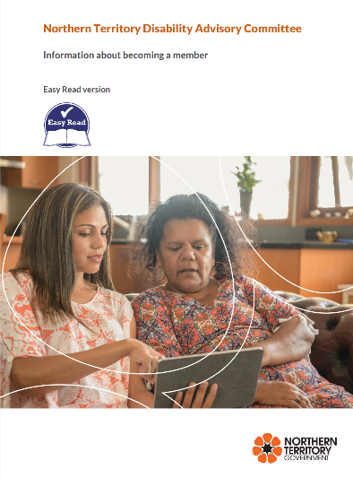

Please refer to the Northern Territory Disability Advisory Committee (DAC) Information about becoming a member to assist completing this application.

Your details
Name:

Date of birth:

Gender: ☐ Male ☐ Female ☐ Indeterminate/Intersex/Unspecified

Postal Address:

Telephone:
Mobile:

Email:

Do you live in the Northern Territory? ☐ Yes ☐ No

If yes, please tell us where you live:

Are there other places in the Northern Territory, where you have lived or that are important to you? If yes, please tell us where:

Do you have a disability? ☐ Yes ☐ No
If yes, does your disability affect your:
☐ body
☐ senses
☐ the way you think
☐ mental health

Are you a carer of a person with disability? ☐ Yes ☐ No
What is your relationship to the person?

Aboriginal and Torres Strait Islander

Are you of Aboriginal and/or Torres Strait Islander decent?
☐ Yes, Aboriginal
☐ Yes, Torres Strait Islander
☐ Both, Aboriginal and Torres Strait Islander
☐ No

Culturally and Linguistically Diverse (CALD)
Do you speak English as a second language? ☐ Yes ☐ No
If yes, what other language/s do you speak?

Your experience
Do you have expertise and or lived experience with any of the following government service systems:

☐ NT Justice System, including courts, youth detention, prison and the police

☐ NT Health System, including hospitals, Community Health Centres or other services that take care of your health

☐ NT Education System, the NT Education System, including schools and universities

☐ National Disability Insurance Scheme, for example if you are an NDIS participant

☐ Other please specify:

Please tell us about your work, study, volunteering experience or other roles that you have had that will help you as a DAC member.

Interests
Please tell us about your interests and your involvement in the community. For example are you involved in any sports, hobbies, social activities or community groups?

Please tell us about any leadership roles you have had. For example if you have been part of a group or represented yourself or others in any forums.

DAC Membership
Please tell us about what you think are important issues for people with disability?

Please tell us why you want to be on the DAC. What you would like the DAC to achieve?

Roles and Responsibilities
Have you read and understood the Terms of Reference for the DAC?
☐ Yes ☐ No

Please tell us how long you would like to be a member for:
☐ 1 year ☐ 2 years ☐ 3 years ☐ 4 years ☐ 5 years ☐ 6 years
Please tell us if you would like to be considered for a Chair or Vice-Chair position(s):
Chair ☐ Yes ☐ No
Vice Chair ☐ Yes ☐ No

Availability and support requirements
Are you able to attend face-to-face meetings?
☐ Yes ☐ No

Are you able to dedicate time between meetings to do activities for the DAC?
☐ Yes ☐ No

Please tell us about your support requirements to attend meetings, such as transport, support person, an interpreter or dietary requirements?

Any other information
Please include any other relevant information to support this application.

Referees
Please provide the names and contact details of two referees who know about your experience, understanding and ability to be a community representative on disability access and inclusion in the Northern Territory. Referees may be contacted to discuss your application.

Referee one:
Name:
Relationship to applicant:
Telephone:
Mobile:
Email:

Referee two:
Name:
Relationship to applicant:
Telephone:
Mobile:
Email:

Approval
Please sign below if you agree:
- to providing this application to the DAC Secretariat for consideration as a DAC Member; and
- that the DAC Secretariat may keep your application for a period of two years for future DAC Member appointments.

Applicants will be contacted to attend a face to face/telephone interview.

Signature: _______________________ Date: _____________________

The DAC Secretariat will accept referee applications completed on behalf of the applicant provided the applicant provides approval and the referee completes section below*.
*Referee applications
Please provide information on how you have developed the application in consultation with applicant.

Referee Signature: _______________________ Date: ___________________

Contact us
We will accept video or voice applications.
Please return the completed form to the Office of Disability by email or post to the email/ address below.
If you want more information on the application process or organise submitting a video or voice application please contact the DAC Secretariat on:
