Due for review: 27/09/2024

Public Health Management of Crusted Scabies

# Contents

Contents 1

Applicability 1

Guideline statement 2

Relationship to parent policy 2

Guideline details 2

Public health objectives 2

Notification 2

Disease information 3

Public health significance 4

Cases 6

Contacts 8

Special situations 11

Preventative measures 12

Resources 12

Definitions 13

Document History 14

National Safety and Quality Health Service standards 14

Appendicies 15

Appendix A: References 15

Appendix B: Crusted scabies contact screening form 16

Appendix C: Visual factsheet for contacts of crusted scabies 18

# Applicability

Crusted scabies has been notifiable in the Northern Territory (NT) since 2016. It is not currently a notifiable disease in other states and territories. This guideline details procedures for the verification of notifications and their reporting to the NT Notifiable Diseases System (NTNDS), along with the public health management of cases of crusted scabies.

The target audience is Centre for Disease Control (CDC) surveillance staff, who are responsible for coordinating the public health response. This guideline can also be used by staff working in other areas who may assist in carrying out the public health response e.g. primary health care. The makeup of the multidisciplinary team involved in a public health response will vary by community, and is dependent on availability and capacity of local service providers.

This guideline does not provide advice about the clinical management of crusted scabies cases. For clinical guidance, refer to the Simple, Complicated and Crusted Scabies NT Health Guideline on Policy Guidance Centre (PGC), or [CARPA Standard Treatment Manual](https://remotephcmanuals.com.au/).1 See also the end of this document for links to other resources such as guidelines, training, and educational materials.

# Guideline statement

This guideline provides information to support the public health management of crusted scabies cases, contacts and outbreaks in the NT.

# Relationship to parent policy

This guideline forms part of the following policy suite for this topic. Related documents are listed below:

* Crusted (Norwegian) Scabies Grading Scale and Treatment TEHS Guideline
* Crusted Scabies Management LBC RDPH Guideline
* Healthy Skin Program: Guidelines for Community Control of Scabies, Skin Sores, Tinea and Crusted Scabies in the Northern Territory

# Guideline details

## Public health objectives

* To support the notification and management of crusted scabies cases
* Identification of contacts who are at risk of developing scabies or crusted scabies
* Communicating with primary health providers to ensure that:
  + Relevant contacts receive screening and treatment or chemoprophylaxis as appropriate
  + All contacts receive education about scabies and how to prevent it
  + Contacts are aware of the importance of a ‘scabies free zone’ for the case to return to

## Notification

Under the Notifiable Diseases Act 1981 (Northern Territory), a case of crusted scabies is to be notified by a medical practitioner or laboratory. Crusted scabies may be re-notified in the same person after 6 months.

## Disease information

### Infectious agent

|  |  |
| --- | --- |
| Scabies | A disease caused by infestation of the skin with the mite *Sarcoptes scabiei* |
| Simple scabies | Scabies infestation without superimposed bacterial infection or crusting |
| Complicated scabies | Scabies infestation complicated by secondary bacterial infection and/or immunological sequelae of infection such as acute post-streptococcal glomerulonephritis (APSGN) or acute rheumatic fever (ARF) leading to rheumatic heart disease (RHD) |
| Crusted scabies (previously known as Norwegian Scabies) | A hyper infestation with scabies mites, commonly occurring in the setting of immunological deficiency, resulting in hyperkeratotic scaling and/or crusting with extreme mite burden. |

**Table 1: Clinical manifestations of infestation with *Sarcoptes scabiei.***

### Mode of transmission

Mites are generally transferred from person to person by direct contact with skin and can burrow into the skin within 2.5 minutes. Scabies mites can survive off a human host for a short time only, up to approximately 3 days, but potentially for several days longer if attached to shed skin in dark, moist environments.

In crusted scabies where there is a much higher mite burden and shedding of skin, scabies can also be spread through clothing and linen that have been used immediately beforehand. Individuals with crusted scabies are highly infectious to others, and undiagnosed cases of crusted scabies can lead to recurrent infection of household members and be core-transmitters in scabies outbreaks such as in residential care facilities, most notably nursing homes.

### Incubation period

Following fertilisation on the skin surface, the female mite burrows into the top layer of the skin, where she deposits eggs. The burrowing action causes intense itching, especially at night when the body becomes warm through bed clothes or following a hot bath or shower. The eggs develop into adult mites within 2-3 weeks, and the female mites are subsequently fertilised, thus repeating the cycle.

### Infectious period

In persons who have not been previously infected, symptoms usually occur 2-6 weeks following initial exposure. In persons who have been previously infected, symptoms can occur within 1-4 days.

### Clinical presentation

Scabies infestation may be simple or complicated (e.g. with bacterial infection). Simple or complicated (non-crusted) scabies usually involves a total of 5-20 mites over the whole body. Scabies papules and scratch marks are commonly found in the web spaces between fingers and toes, and on the anterior surfaces of the wrists and elbows. Other common sites include axillary folds, belt line, thighs, abdomen and buttocks. Despite a relatively low mite burden, even simple scabies can be associated with significant morbidity and flow-on effects such as missed school, social stigma and isolation.2

Complicated scabies can manifest as bacterial infection such as skin sores/impetigo or cellulitis, most commonly due to *Streptococcus* and *Staphylococcus* species. These infections may in turn lead to further complications such as acute post-streptococcal glomerulonephritis (APSGN), invasive group A streptococcal (iGAS) infection, or acute rheumatic fever (ARF) leading to rheumatic heart disease (RHD).

When hyper infestation of mites occurs the condition is known as crusted scabies (previously Norwegian scabies), which can involve thousands to millions of mites over the person’s body. Crusted scabies is often associated with underlying immune deficiencies such as Human Immunodeficiency Virus (HIV), cancer, chemotherapy, and neurological illnesses, although the majority of crusted scabies in the NT has not been associated with identified underlying immune problems. In Central Australia it has been associated with Human T-cell Lymphotrophic Virus 1 (HTLV-1).

The rash in crusted scabies manifests as scaling and crusting of skin, often on buttocks, armpits, elbows, knees, hands and feet, but sometimes involving the scalp and ears. Palms, soles of feet, elbows and knees may be fissured. Cases can range from mild with only a few patches, to severe infestation covering the entire body. It may be misdiagnosed as other conditions such as psoriasis, fungal infection or diseases in which hyperkeratosis is a feature.

Crusted scabies has historically been associated with high mortality3, with secondary skin sepsis resulting in life threatening sepsis. Morbidity from crusted scabies can be severe, with social stigma and isolation major issues. Cases of crusted scabies are also at high risk of recurrence from reinfection after initial successful treatment4, and require ongoing monitoring to prevent this.

## Public health significance

Since crusted scabies became notifiable in the NT in March 2016, 452 cases have been notified (Figure 1).

The greatest number of cases notified were from the Darwin region (209/451, 46%), with the highest annual incidence rate in the East Arnhem region (Figure 2).

The majority of notifications 432/452 (96%) were Aboriginal people and 290/452 (64%) were female. Most Aboriginal cases were notified in the 50-59 year age group (272/432, 61%) but the highest annual incidence rate occurred in those aged 60-69 years with an annual incidence rate of 284 cases per 100,000 per year (Figure 3).

The 452 notifications were attributed to 398 individuals; 60/398 (15%) were notified 2 or more times. The majority of cases (406/452 90%) were hospitalised with a median stay of 13 days (min – max); 86/452 (19%) of cases attended renal dialysis; 4 cases (1%) died. The grading of notified crusted scabies cases are shown in table 2 below.

|  |  |  |
| --- | --- | --- |
| Grading | Notifications | Proportion (%) |
| Grade 1 | 180 | 40 |
| Grade 2 | 164 | 36 |
| Grade 3 | 64 | 14 |
| Not graded / unknown | 44 | 10 |

**Table 2: Crusted scabies cases notified in NT by grading, Mar 2016 - Jul 2023 (n=452)**

## Cases

### Case definition

**All confirmed and probable cases must be notified to the local Public Health Unit (PHU).**

|  |
| --- |
| **Confirmed case**  A confirmed case requires laboratory suggestive evidence AND clinical evidence.  **Laboratory suggestive evidence**  Detection of scabies mite or eggs by microscopy of a skin scraping.  **Clinical evidence**  Visible skin abnormalities consistent with crusted scabies and verified1 by an infectious diseases physician or dermatologist.  1. Verification can be by clinical photography.  **Probable Case**  A probable case requires clinical evidence only. A skin scraping must be sought for all crusted scabies diagnoses. If the initial scraping is negative (no scabies mite or eggs seen) then a repeat scraping should be collected. In the event that scraping(s) are negative, then the infectious disease consultant or dermatologist must be re-contacted to confirm the notification of a probable case of crusted scabies, and a public health response will be initiated. |

**Table 3: Crusted scabies notifiable case definition.**

For patients from remote areas, clinical assessment by infectious diseases or dermatology may be done remotely e.g. via photo or teleconference. As part of the clinical evidence, the case should be graded by the relevant specialist5. Cases may be classed as grade 1, grade 2, or grade 3. See other resources such as the Simple, Complicated and Crusted Scabies NT Health Guideline on PGC or [CARPA Standard Treatment Manual](https://remotephcmanuals.com.au/)1 for more information on how to determine the grading.

For patients with negative skin scrapings and high clinical suspicion of crusted scabies, repeat scrapings are required in order to confirm the case. In the event that the scraping(s) are negative, then the infectious disease consultant or dermatologist must be re-contacted to confirm the notification of a probable case of crusted scabies, and a public heath response will be initiated.

### Recurrence

A recurrence is defined as a repeat diagnosis of crusted scabies that occurs >=6 months since the previous notified diagnosis date. This is irrespective of whether the previous episode was adequately treated.

If a case of confirmed crusted scabies was last notified on the NTNDS with a diagnosis date <6 months from the current diagnosis date, complete the public health response but do not renotify on NTNDS. Such cases are most likely to be recurrence of inadequately treated crusted scabies rather than a new infection, especially if within 3 months of the initial diagnosis.

### Case management

Note that clinical management and education for crusted scabies patients are the responsibility of the treating team. See Simple, Complicated and Crusted Scabies NT Health Guideline on PGC or [CARPA Standard Treatment Manual](https://remotephcmanuals.com.au/)1 for more information.

#### Verify notification

Notifications of crusted scabies may be received from either the laboratory or clinicians. In either situation, notifications require further verification to ensure the full case definition is met.

**If notified of scabies on skin scraping by laboratory** - assess for clinical confirmation of the case by infectious diseases or dermatology:

* For patients in hospital, review medical records to determine if crusted scabies has already been clinically diagnosed by infectious diseases or dermatology. If not, consultation may need to be requested and this should be discussed with the treating team.
* For patients not in hospital, contact the referring doctor or health centre manager to discuss the clinical impression. If there is concern for crusted scabies, check whether it has been confirmed by infectious diseases or dermatology.
* Confirmation can be done remotely using clinical photography or teleconference with consent for patients in community settings or regional hospitals.
* Note that a positive skin scraping may also be due to simple or complicated scabies instead of crusted scabies, in which case no further public health follow up by CDC is required.

**If notified by clinician** – assess for laboratory confirmation on skin scraping:

* Confirm the qualifications of the notifying clinician and whether infectious diseases or dermatology consultation is still required (see above).
* Confirm that a skin scraping has been taken, and sent to the laboratory. Results may need to be requested from private pathology laboratories.
* If a skin scraping has not been taken, recommend this to the treating clinician.
* If the skin scraping is pending, ensure the result is followed up for confirmation of the case. Due to the time taken for skin scrapings to be processed, it may be appropriate to commence a public health response while awaiting laboratory results for clinically convincing cases – this should be decided by CDC at a high level.
* If the skin scraping is negative, but there is a strong clinical suspicion of crusted scabies by infectious diseases or dermatology, repeat skin scrapings are recommended. In the event that scraping(s) are negative, then the infectious disease consultant or dermatologist must be re-contacted to confirm the notification of a probable case of crusted scabies, and a public health response will be imitated.

Once the case is verified as meeting the confirmed case definition, ensure adequate information is collected for NTNDS core and enhanced data collection. See further information below under Documentation.

#### Exclusion period (‘Time out’) for cases

For crusted scabies cases managed in hospital, isolation and contact precautions are recommended during treatment. Cases managed in community should have infectious disease or dermatology consultation to determine a management plan, including any isolation requirements and clearance relevant to the local setting. See Simple, Complicated and Crusted Scabies NT Health Guideline on PGC for more information.

#### Scabies Free Zone

Maintenance of Scabies Free Zones in households relies on breaking the skin to skin transmission of scabies, by ensuring everyone in the household and visiting close contacts, undertake treatment together. Ensuring that scabies mites are not present in the household environment is also an important part of maintaining a scabies free zone especially where cases are being managed in the community.

Treatment of the house should be coordinated with contact tracing and should begin when initial treatment of close contacts commences and completed prior to the return of the case to the household. Education should be provided so the family can take responsibility for cleaning of the household. Aspects of household cleaning include:

* **Clothes and linens** – Machine wash clothes, bedding and towels used by the patient with crusted scabies on a hot wash (at least 50°C for 10 minutes). Alternatively Tumble drying clothes and linen at 50°C for 10 minutes will also kill mites and eggs.. If washing facilities are not available, or for items that cannot be washed, remove from any human contact for 8 days e.g. by storing in a sealed bag.5
* **Mattresses and soft furnishings** – Vacuum or sweep mattresses and soft furnishings such as lounges. If possible, they should also be left in direct sunlight for at least several hours. Pyrethroid based insecticide sprays can also be used to decontaminate (use as directed on the product label).
* **General cleaning** - Thoroughly vacuum, or sweep then mop, to remove dust and skin particles which could harbor mites. Dispose of the vacuum bag or sweepings in an outside rubbish bin.
* **Check infrastructure** - Ensure all wet areas in the home are functioning. If the household washing and bathing facilities are in need of repair or replacement, the householders should be assisted to contact the local housing maintenance provider. The PHU Environmental Health Branch can also be contacted to assist with checking that health hardware is functional. Fumigation of the house is not necessary if the above measures are followed. However, in severe cases and where the family wishes, insecticide bombs containing pyrethroids can be used to help kill any mites remaining. Follow instructions and safety precautions prior to use.

For complex situations such as recurrent crusted scabies cases, multiple cases of crusted scabies within one household, or cases occurring in an institutional setting, consider discussion with the PHU Environmental Health Branch for further advice and a multi-disciplinary case conference may be appropriate to coordinate actions.

## Contacts

### Contact definition

The period at risk for all contact types is the 14 days prior to the case being admitted to hospital or commencing treatment by primary health care providers.

Close contacts include all of the following:

* ***Household******contact****:* anyone residing in the primary place of resident of the case of crusted scabies during the period at risk.
* ***Institutional contact:*** anyone in an institution who has spent at least 24 hours in the same room or stayed overnight in the same room or shared a bathroom with a case of crusted scabies during the period at risk. An institution is a residential facility including, but not limited to, nursing homes, residential hostels, homeless shelters, correctional centres, and military barracks.
* ***Sexual or intimate******contact****:* anyone who has had sexual or other intimate contact with a case during the period at risk.
* ***Homeless******contact****:* anyone who spent at least 24 hours in close proximity or sharing bedding with a case of crusted scabies during the period at risk.
* ***Carers****:* family, friends, or staff who helped the case with their activities of daily living such as washing, mobilising, dressing and toileting, during the period at risk.
* ***Direct******contact****:* any other person that has had direct physical contact with the crusted scabies site or direct physical contact with fomites such as bedding, clothing, towels or skin cells that have been shed during the period at risk. For healthcare workers who have had direct contact with the patient, determine risk on a case-by-case basis.

### Contact identification

After the case has been confirmed, identify the case’s place of residence and compile a list of household contacts and any other close contacts.

For cases managed in hospital, this may be done by: CDC staff visiting the patient on the ward to gather information about their household, reviewing medical records, discussing with the treating team, and/or by contacting the usual primary health care provider. CDC staff may identify the case’s residence during the 14 days prior to admission to hospital, and then liaise with the local primary health care provider to conduct a home visit to gather the full list of contacts.

For cases managed outside of hospital, the place of residence in the 14 days prior to commencing treatment should be identified on discussion with the primary health care provider.

Community clinics and primary healthcare facilities play a vital role in reducing the risk of recurrent disease and the ongoing burden of scabies in the broader community. When requesting assistance from the primary health care provider, email or fax the crusted scabies public health response paperwork to the relevant clinic for completion (Appendix B). This may include assistance with identification, as well as education and management of contacts.

Any contact tracing required in the hospital setting (e.g. other patients or staff members) should be conducted by the local infection prevention and control team.

### Contact education

Education should be provided to both cases and contacts of crusted scabies. Education of cases of crusted scabies is essential for successful treatment and prevention of recurrence, and this is the responsibility of the treating team.

Education of contacts is part of the public health response. It is important to remember in all interactions that scabies may be associated with stigma and shame. Education must be conducted in a non-judgmental and culturally safe manner, paying attention to preferred language and setting. A visual factsheet for contacts of crusted scabies is available (Appendix C).

|  |
| --- |
| Education about crusted scabies specifically, and healthy skin in general, should be provided to all close contacts. Education should be tailored to the individual, including:   * What is scabies and crusted scabies, and what are the symptoms. * Consequences of untreated scabies. * How scabies is transmitted from person to person. * How to prevent scabies, including treatment of crusted scabies contacts. * The importance of early presentations to the local primary health care provider for people with symptoms of scabies or crusted scabies.   Written and/or pictorial CDC fact sheets can be provided to assist with education. See Appendix B for links to the CDC fact sheets, as well as other educational resources. |

**Table 4: Education for crusted scabies contacts.**

### Contact management

Close contacts should have a skin check by a health professional (depending on location, this may be completed by CDC or local primary health care staff) to assess for the presence of scabies and/or other skin health concerns including:

* Simple, complicated or crusted scabies.
* Bacterial infections e.g. skin sores or boils.
* Fungal infections e.g. tinea.
* Dry skin.
* Skin breaks e.g. wounds.

If crusted scabies is suspected, the patient should be managed as for a new case, including skin scrapings and discussion with infectious diseases and/or dermatology for clinical confirmation.

All close contacts of a crusted scabies case should be offered either scabies treatment (if clinical evidence of scabies) or chemoprophylaxis (if no clinical evidence of scabies). The treatment regimen will depend on findings of the skin check:

* If scabies is diagnosed - treat as per Section 6.4.1.
* If no scabies is diagnosed - offer scabies chemoprophylaxis as per Section 6.4.2.

It is also essential for healthy skin that any other skin concerns are treated at the same time. Skin sores can lead to consequences such as acute post streptococcal glomerulonephritis (APSGN), acute rheumatic fever (ARF) or invasive group A streptococcal infection (iGAS) and should be managed as a priority. Fungal infections or dry skin can cause chronic itch, resulting in scratches and skin breaks that can lead to bacterial infection.

For clinical guidance on the treatment of other common skin conditions, see local clinical guidelines such as [CARPA Standard Treatment Manual](https://remotephcmanuals.com.au/).1

#### Treatment for contacts with clinical evidence of scabies

|  |
| --- |
| First line treatment: contact with clinical evidence of scabies  Permethrin 5% cream (adult and child) topical with repeat application in 7-14 days  **OR**  Ivermectin (adult and child ≥5 years and ≥15kg) 200 micrograms/kg orally with food1 with repeat dose in 7-14 days  *1. Contraindicated in pregnancy and breastfeeding. Pregnancy test persons of childbearing potential.* |

**Table 5: Treatment for contacts with clinical evidence of scabies.**

Topical permethrin and oral ivermectin are both first line treatments for scabies in children and adults. 7 They appear to have similar efficacy. Considerations in deciding between treatment options include:

* Patient allergies or history of adverse effects including skin reactions to topical treatment.
* Prior treatment failure.
* Patient preference.
* Ease of administration.
* Access to medication and costs. Note that as of April 2022 ivermectin is available on the PBS as a first-line treatment for scabies for Aboriginal and Torres Strait Islander people.

Correct application of permethrin cream is important for effective treatment. Provide education about how to apply the cream. It should be applied to clean, dry skin over the whole body including scalp and face and behind ears (avoiding eyes, lips and mouth) and left on for at least 8 hours (6-8 hours in babies <6 months). This is best done at night. The visual crusted scabies fact sheet (Appendix C) provides useful guidance.

For adults or children who are unable to receive either permethrin or ivermectin, alternative treatments include crotamiton 10% cream, sulfur 5% in white soft paraffin, or benzyl benzoate 25% emulsion (diluted for children). See the Simple, Complicated and Crusted Scabies NT Health Guideline on PGC or seek expert advice for more information about treatment of scabies in these situations.

#### Chemoprophylaxis for contacts with NO clinical evidence of scabies

|  |
| --- |
| First line chemoprophylaxis: contact with NO clinical evidence of scabies  Permethrin 5% cream (adult and child) single application |

**Table 6: Chemoprophylaxis for contacts with no clinical evidence of scabies.**

See Section 6.4.1 or [CARPA Standard Treatment Manual](https://remotephcmanuals.com.au/)1 for more information about administration of permethrin.

In some circumstances alternative treatments may be offered for chemoprophylaxis. For example, a single dose of ivermectin may be considered for contacts in whom permethrin is not safe, tolerable or practical. This must be prescribed by a medical officer and considered on a case-by-case basis. Seek expert advice as required.

#### Exclusion period (‘Time out’) for contacts

Crusted scabies close contacts **without** evidence of scabies do not require any exclusion period, they can continue attending work or school.

Crusted scabies close contacts **with** clinical evidence of scabies can return to work or school the day after they have started appropriate treatment.7

## Special situations

Special situations for the crusted scabies public health response include institutional cases. Institutions vary substantially, for example according to:

* Housing capacity
* Interactions between residents, staff, and visitors
* Residents’ level of independence or need for assistance with activities of daily living
* Residents’ frailty and medical comorbidities
* Staff movement between areas
* Cleaning protocols – environmental, linen, laundry, personal hygiene
* Meal services and food protocols.

When crusted scabies occurs in an institutional resident or worker, CDC surveillance staff, local primary health care services (where relevant), and facility management should work closely together to assess risks for close contacts, tailor and coordinate the public health response.

## Preventative measures

Early diagnosis and prompt treatment helps to prevent the spread of scabies and progression to crusted scabies. Like many other common skin infections, crusted scabies may be preventable through action on the social determinants of health and primordial, primary and secondary prevention measures, as below.

|  |  |
| --- | --- |
| **Primary prevention** | Measures that treat simple scabies infections early can prevent complications and progression to crusted scabies.  Scabies as well as other skin disease such as skin sores and tinea are very common in the NT and cause a large burden of primary disease and secondary complications.  Healthy skin guidelines:   * [National Healthy Skin Guideline: for the Prevention, Treatment and Public Health Control of Impetigo, Scabies, Crusted Scabies and Tinea for Indigenous Populations and Communities in Australia](https://infectiousdiseases.telethonkids.org.au/resources/skin-guidelines/)5 * Recognising & Treating Skin Infections: A visual clinical handbook6 * [Healthy Skin Program - Guidelines for Community Control of Scabies, Skin Sores Tinea and Crusted Scabies in the NT7)](https://digitallibrary.health.nt.gov.au/prodjspui/bitstream/10137/698/1/Healthy%20Skin%20Program%202015.pdf)   Optimisation of social determinants of health and access to health hardware.   * Households: support healthy living practices, including washing people, regular washing of clothes and bedding, and reducing the negative impacts of overcrowding   Institutions: adhere to infection control protocols for hand hygiene, cleaning and laundry |
| **Secondary prevention** | Patients with crusted scabies require long term monitoring and early treatment of recurrent scabies to prevent progression to crusted scabies. Secondary prevention with supervised 2nd-weekly benzyl benzoate is sometimes recommended by infectious diseases (see clinical guidance for more information). |
| **Education** | Education for the general public and for clinicians to recognise symptoms, signs, and risk factors. |

**Table 7: Prevention of scabies and crusted scabies.**

## Resources

Resources for the public health response:

|  |  |  |
| --- | --- | --- |
| Name of resource | Comment | Resource location |
| **Notification of a notifiable disease** | For clinicians notifying CDC of a notifiable disease. | [Public health and notifiable diseases | NT Health](https://health.nt.gov.au/public-health-notifiable-diseases) |
| **Crusted scabies public health response form (internal)** | For recording close contacts. | [Public Health Response – NT Health CDC Staff Access only](http://internal.health.nt.gov.au/teamsites/cdc/_layouts/15/start.aspx#/Public%20Health%20Response/Forms/AllItems.aspx) |
| **How to do a skin scraping** | Reference video for collection of skin scraping. | [Australian Indigenous HealthInfoNet resources](https://healthinfonet.ecu.edu.au/key-resources/resources/38010/?title=Skin+scrapings+procedure+%5Bvideo%5D&contentid=38010_1) |

Resources for patients, communities and health professionals:

|  |  |  |
| --- | --- | --- |
| Name of resource | Description | Resource location |
| **Scabies fact sheet** | Educational resource for the general public. | Patient resrouces: [Scabies | NT.GOV.AU](https://nt.gov.au/wellbeing/health-conditions-treatments/parasites/scabies)  Health professional resources: [Scabies and crusted scabies](https://health.nt.gov.au/public-health-notifiable-diseases/scabies) |
| **Visual factsheet for contacts of crusted scabies** | Educational resource for contacts (appropriate for low literacy). | Health professional resources: [Scabies and crusted scabies](https://health.nt.gov.au/public-health-notifiable-diseases/scabies) |
| **One Disease resource library (Now available on Australian Indigenous HealthInfoNet)** | Resources include a variety of educational videos. | [healthinfonet.ecu.edu.au](https://healthinfonet.ecu.edu.au/key-resources/resources/?kw=&kw=&searchIn_title=1&joiner=OR&ailment%5b%5d=133&searchIn_title=1&joiner=OR&website=aih) |
| **Menzies School of Health Research - Healthy skin story** | Flipchart/presentation on scabies, skin sores and tinea. | [menzies.edu.au/page/Resources/Healthy_Skin_Story](https://www.menzies.edu.au/page/Resources/Healthy_Skin_Story/) |
| **National Healthy Skin Guideline: for the Prevention, Treatment and Public Health Control of Impetigo, Scabies, Crusted Scabies and Tinea for Indigenous Populations & Communities in Australia – 1st edition** | Clinical and public health guidelines. | [infectiousdiseases.telethonkids.org.au/resources/skin-guidelines/](https://infectiousdiseases.telethonkids.org.au/resources/skin-guidelines/) |
| **Keeping Skin Healthy:**  **A Handbook for Community Care Workers in the Pilbara** | Flipchart/presentation on scabies and other common skin infections. | [CCW Handbook for Healthy Skin](https://infectiousdiseases.telethonkids.org.au/siteassets/media-docs---wesfarmers-centre/handbook-for-healthy-skin.pdf?utm_content=218016602&utm_medium=social&utm_source=linkedin&hss_channel=lcp-18416804) |
| **RAHC Online module: Managing Scabies and Crusted Scabies** | Online learning for clinicians. | [eLearning | Remote Area Health Corps (rahc.com.au)](https://www.rahc.com.au/elearning-resources/elearning) |

# Definitions

The following definition(s) are relevant to this guideline.

|  |  |
| --- | --- |
| Term | Definition |
| APSGN | Acute post-streptococcal glomerulonephritis |
| ARF | Acute rheumatic fever |
| CARPA | Central Australian Rural Practitioners Association |
| CDC | Centre for Disease Control |
| HIV | Human Immunodeficiency Virus |
| HTLV-1 | Human T-cell Lymphotrophic Virus 1 |
| iGAS | Invasive group A streptococcal |
| NTNDS | Northern Territory Notifiable Disease System |
| PBS | Pharmaceutical Benefits Scheme |
| PGC | Policy Guidance Centre |
| PHU | Public Health Unit |
| RAHC | Remote Area Health Corps |
| RHD | Rheumatic heart disease |

# Document History

|  |  |  |
| --- | --- | --- |
| Document metadata | | |
| **Document Owner** | Director Centre for Disease Control NT Health | |
| **Document Approver** | Karen Stringer, Chief Medical Officer | |
| **Author** | Dr Georgina Taylor | |
| **HEALTHINTRA-ID** | HEALTHINTRA-1627664142-59406 | |
| **Content Manager ID** | EDOC2023/251760 | |
| **Version Number:** | Version: 1.1 |  **DO NOT EDIT THIS FIELD** | **Approved Date:** 27/09/2023 | **Review Date:** 27/09/2024 |

|  |  |  |
| --- | --- | --- |
| **Content amendment** | | |
| **Approver** | Karen Stringer, Chief Medical Officer | **Approved Date:** 08/12/2023 |
| **Content Change Summary:** Updated Case definition and related sections. | | |

# National Safety and Quality Health Service standards

|  |  |  |  |  |  |  |  |
| --- | --- | --- | --- | --- | --- | --- | --- |
| **National Safety and Quality Health Service standards** | | | | | | | |
| cid:image001.jpg@01D658ED.D030F090  Clinical Governance | cid:image002.jpg@01D658ED.D030F090  Partnering with Consumers | cid:image003.jpg@01D658ED.D030F090  Preventing and Controlling Healthcare Associated Infection | cid:image004.jpg@01D658ED.D030F090  Medication Safety | Comprehensive care icon  Comprehensive Care | cid:image006.jpg@01D658ED.D030F090  Communicating for Safety | cid:image007.jpg@01D658ED.D030F090  Blood Management | cid:image008.jpg@01D658ED.D030F090  Recognising & Responding to Acute Deterioration |
|  |  |  |  |  |  |  |  |

# Appendicies

## Appendix A: References

1. CARPA Standard Treatment Manual (8th edition). [Internet] 2022. [Accessed on 8 August 2023]. Available from: <https://remotephcmanuals.com.au/>.
2. Centre for Disease Control, Northern Territory Department of Health. Healthy Skin Program: Guidelines for Community Control of Scabies, Skin Sores, Tinea and Crusted Scabies in the Northern Territory. [Internet] 2015. [Accessed on 8 August 2023]. Available from: <http://hdl.handle.net/10137/698>.
3. Lynar S, Currie BJ, Baird R. Scabies and mortality. *Lancet Inf Dis.* 2017;12:1234. doi: <https://doi.org/10.1016/S1473-3099(17)30636-9>.
4. Hasan T, Krause VL, James C, Currie BJ. Crusted scabies; a 2-year prospective study from the Northern Territory of Australia. *PLoS Negl Trop Dis.* 2020;14(12):e0008994. doi: <https://doi.org/10.1371/journal.pntd.0008994>.
5. Davis JS, McGloughlin S, Tong SY, Walton SF, Currie BJ. A novel clinical grading scale to guide the management of crusted scabies. *PLoS Negl Trop Dis*. 2013;7(9):e2387. doi: <https://doi.org/10.1371/journal.pntd.0002387>.
6. Bernigaud C, Fernando DD, Lu H, Taylor S, Hartel G, Chosidow O et al. *Journal of American Academy Dermatology.* 2020;83(1):241-245. doi: <https://doi.org/10.1016/j.jaad.2019.11.069>.
7. Currie BJ, McCarthy JS. Permethrin and ivermectin for scabies. *N Engl J Med.* 2010;362:717-722. doi: <https://doi.org/10.1056/NEJMct0910329>.
8. Centre for Disease Control, Northern Territory Department of Health. Time Out. Minimum periods of exclusion from school, pre-school and childcare facilities for children or staff with, or exposed to infectious diseases. [Internet] 2023. [Accessed on 8 August 2023]. Available from: <https://hdl.handle.net/10137/1011>.

## Appendix B: Crusted scabies contact screening form

Available from [Public Health Response](http://internal.health.nt.gov.au/teamsites/cdc/_layouts/15/start.aspx#/Public%20Health%20Response/Forms/AllItems.aspx) website by NT Health CDC staff only.

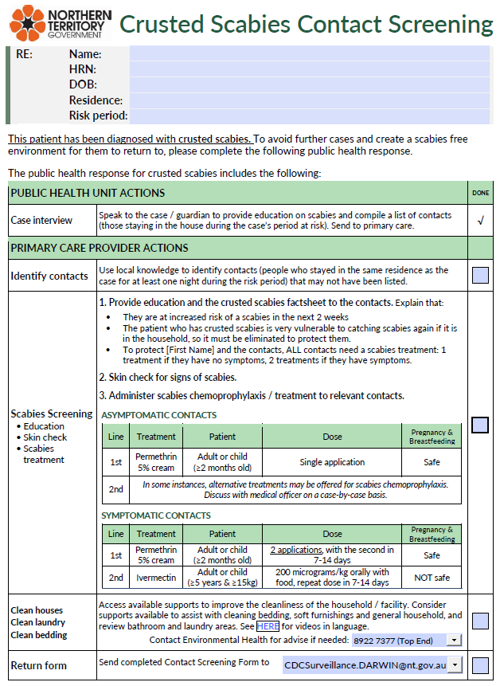

SAMPLE

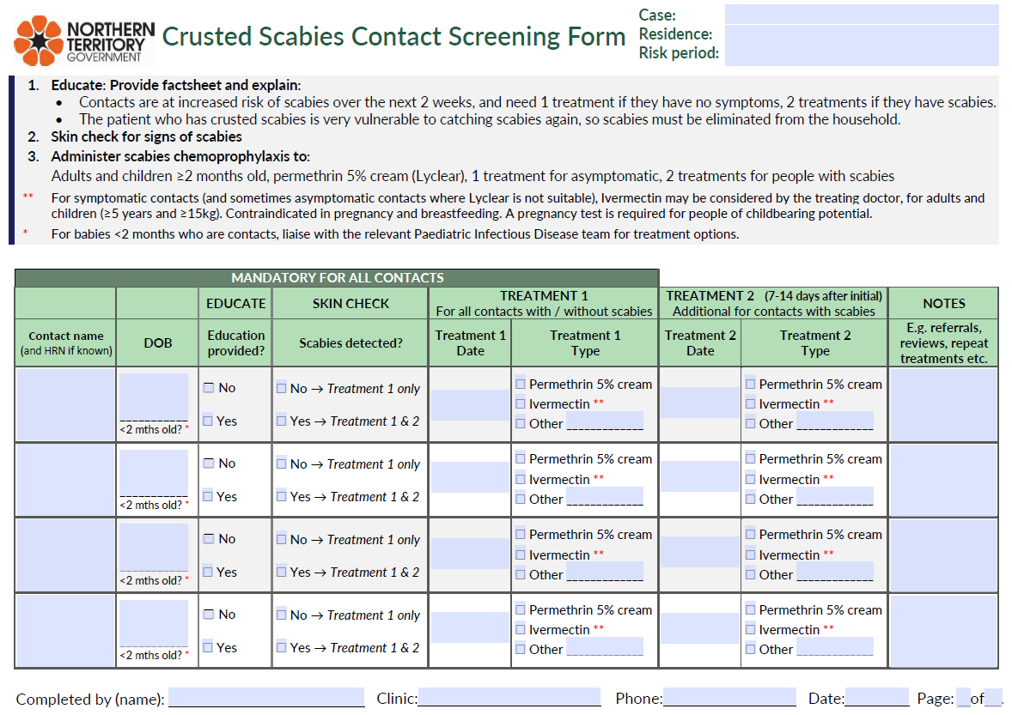

SAMPLE

## Appendix C: Visual factsheet for contacts of crusted scabies

Available from the NT Health [Scabies and crusted scabies](https://health.nt.gov.au/public-health-notifiable-diseases/scabies) internet page. Page 1:

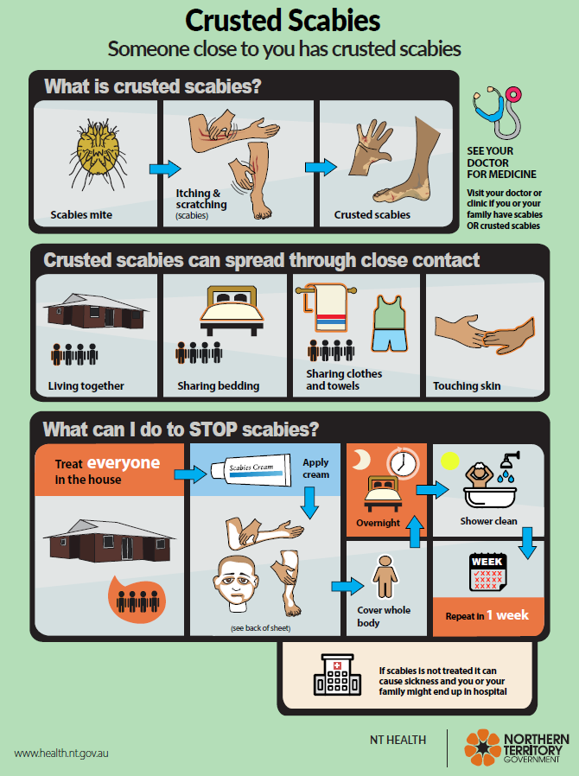

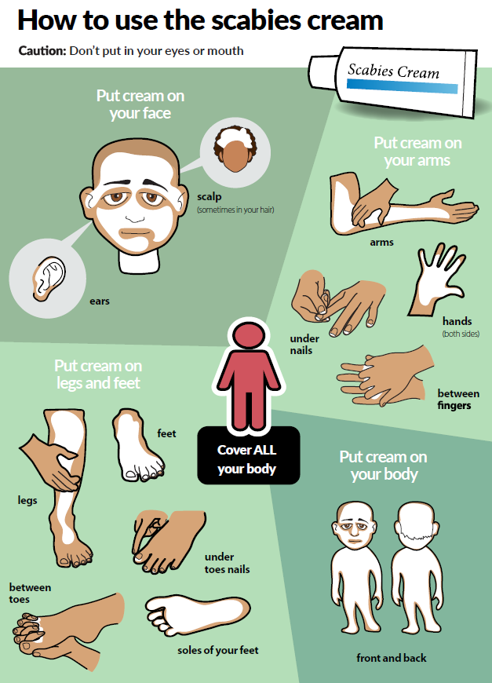Page 2: